多祖源变异数据探索系统
Multi-Ancestry Variant Data Exploration System
1.0
User Manual

Table of Contents
Software operation 2
1. Overview 2
1.1 Description 2
1.2 Modules 3
1.3 Install required R packages 3
2. Shared concepts (Modules 1–3: SNV, INDEL, SV) 3
2.1 Example Pipeline Execution 3
2.2 Command-line Arguments 4
2.3 Input 5
2.3.1 Gene Locus File: <GENE>.xlsx 5
2.3.2 Sample-to-Region Mapping: SampleArea.xlsx 5
2.3.3 Raw VCF variant file 6
2.3.4 VEP-annotated VCF variant file 6
2.4 Data preprocessing 7
2.4.1 Output 7
2.4.2 Steps 8
2.4.3 Notes 8
2.5 Step 1 - Variant burden heatmap 9
2.5.1 Input 9
2.5.2 Output 9
2.5.3 Steps 10
2.5.4 Notes 10
2.6 Step 2 - Bubble plot 11
2.6.1 Input 11
2.6.2 Output 11
2.6.3 Steps 11
2.6.4 Notes 12
2.7 Step 3 - Dual-bubble comparison 12
2.7.1 Input 12
2.7.2 Output 12
2.7.3 Steps 13
2.7.4 Notes 13
2.8 Steps 4&5 - Summary plots 14
2.8.1 Input 14
2.8.2 Output 14
2.8.3 Steps 16
2.8.4 Notes 17
2.9 Step 6 - Track map 17
2.9.1 Input 17
2.9.2 Output 17
2.9.3 Steps 17
2.9.4 Notes 18
3. Combined analysis 18
3.1 Example Pipeline Execution 18
3.2 Command-line Arguments 18
3.2 Input 19
3.2.1 FASTA sequence files 20
3.2.2 Pairwise distance matrices 21
3.2.3 Pairwise dN-dS matrices 21
3.3 Data preprocessing 22
3.3.1 Output 22
3.3.2 Steps 22
3.3.3 Notes 23
3.4 Step 1 - Variability score 23
3.4.1 Input 23
3.4.2 Output 23
3.4.3 Steps 25
3.4.4 Notes 27
3.5 Step 2 - Comparison with evolutionary metrics 27
3.5.1 Input 27
3.5.2 Output 27
3.5.3 Steps 29
3.5.4 Notes 30
3.6 Step 3 - Haplotypes 30
3.6.1 Input 30
3.6.2 Output 30
3.6.3 Steps 33
3.6.4 Notes 34

Software operation

Overview

1.1 Description
This software provides a set of R-based analysis pipelines for characterizing genetic variation across populations. It includes dedicated workflows for single nucleotide variants (SNVs), insertion-deletion variants (INDELs), and structural variants (SVs), as well as an integrated module that performs additional analyses across all variant types.

1.2 Modules
The project consists of four analytical modules:
- SNV Pipeline (snv.r) — processes single nucleotide variants.
- INDEL Pipeline (indel.r) — processes small insertions and deletions.
- SV Pipeline (sv.r) — processes structural variants (deletions, inversions, insertions).
- Combined Analysis (combined_analysis.r) — integrates SNV, INDEL, and SV variants to generate unified multi-variant summaries and extended region-level analyses.

The SNV, INDEL, and SV modules (Modules 1–3) share a similar interface, input structure, and workflow logic. These are described together in the Shared Concepts section. Module 4 (Combined Analysis) is structurally different and is documented separately. All modules can be run independently.

1.3 Install required R packages
Before running any workflow, all required R packages must be installed.
You can automatically install all dependencies by running:

Rscript ./SoftwareInstall.r

This script detects missing libraries and installs them as needed.

Shared concepts (Modules 1–3: SNV, INDEL, SV)
Modules 1–3 (SNV, INDEL, SV) use a unified command-line interface, shared directory structure, and a common workflow architecture. Unless explicitly stated, all three modules use the same framework.

2.1 Example Pipeline Execution
Running the SNV pipeline with all default parameters:

Rscript ./snv.r
Running the INDEL pipeline with all default parameters:

Rscript ./indel.r
Running the SV pipeline with all default parameters:

Rscript ./sv.r
Each command executes the full workflow on the provided example data.

2.2 Command-line Arguments
Shared arguments (all pipelines):
Argument | Description | Default
-g, --gene | Gene basename used for analysis and file matching | "GENE"
-i, --input_dir | Input directory containing all required files and subdirectories | "." (current directory)
-o, --output_dir | Directory to store generated plots  (depending on pipeline) | "snv_results"/  "indel_results"/  "sv_results"
-s, --step | Workflow steps to run (pipeline-specific, see below) | see below
--min_size | Minimum bubble size | 1
--max_size | Maximum bubble size | 10

SNV-specific arguments:
Argument | Default | Step description
-s, --step | “1,2,3,4,5” | 1 = Variant burden heatmap  2 = Bubble map plots  3 = Bubble: synonymous vs nonsynonymous  4 = Summary plots (all consequences)  5 = Summary plots without modifier consequences

INDEL-specific arguments:
Argument | Default | Step description | Additional options
-s, --step | “1,2,3,4,5,6” | 1 = Variant burden heatmap  2 = Bubble map plots  3 = Bubble: PTV vs non-PTV  4 = Summary plots  5 = Summary plots without modifier consequences  6 = Track map | --point_alpha (double, default 0.4)  --indel_colors (character)

SV-specific arguments:
Argument | Default | Step description | Additional options
-s, --step | “1,2,4,5,6” | 1 = Variant burden heatmap  2 = Bubble map plots  4 = Summary plots  5 = Summary plots without modifier consequences  6 = Track map | --point_alpha (double, default 0.4)  --sv_colors (character)

2.3 Input
The modules require a set of gene-specific metadata files and VCF files located in the directory specified by --input_dir. The pipeline reads files in a standardized structure. The expected directory structure for SNV pipeline is:
<input_dir>/
<GENE>.xlsx
SampleArea.xlsx
snv/
<GENE>_snv_vep_output.vcf
<GENE>_snv_raw.vcf

For INDEL and SV pipelines, only the subdirectory name and file suffix differ.

2.3.1 Gene Locus File: <GENE>.xlsx
A single Excel file containing genomic coordinates for one or multiple genes. The pipeline reads columns by fixed position, according to the order defined in the code:
Column position | 2 | 3 | 4 | 5
Content | Chromosome | Start position | End position | Gene name

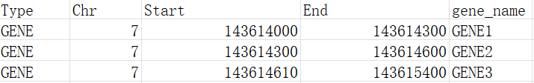
Figure 1 example file GENE.xlsx

2.3.2 Sample-to-Region Mapping: SampleArea.xlsx
A single Excel file that defines the population or region for each sample ID.
The file must contain these columns:
- sample — the sample identifier. Each entry must match the sample IDs present in the VCF files.
- population — the corresponding region or population label assigned to that sample.
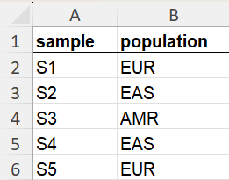
Figure 2 example file SampleArea.xlsx

2.3.3 Raw VCF variant file
An unannotated variant file for the given pipeline.
Pipeline | Example file
SNV | snv/<GENE>_snv_raw.vcf
INDEL | indel/<GENE>_indel_raw.vcf
SV | sv/<GENE>_sv_raw.vcf
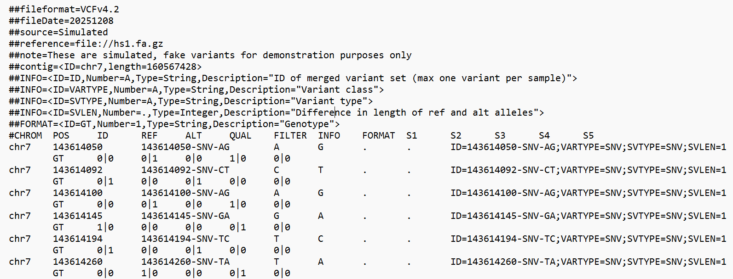Figure 3 part of example file GENE_snv_raw.vcf

2.3.4 VEP-annotated VCF variant file
A VCF file containing functional annotation from VEP.
Pipeline | Example file
SNV | snv/<GENE>_snv_vep_output.vcf
INDEL | indel/<GENE>_indel_vep_output.vcf
SV | sv/<GENE>_sv_vep_output.vcf
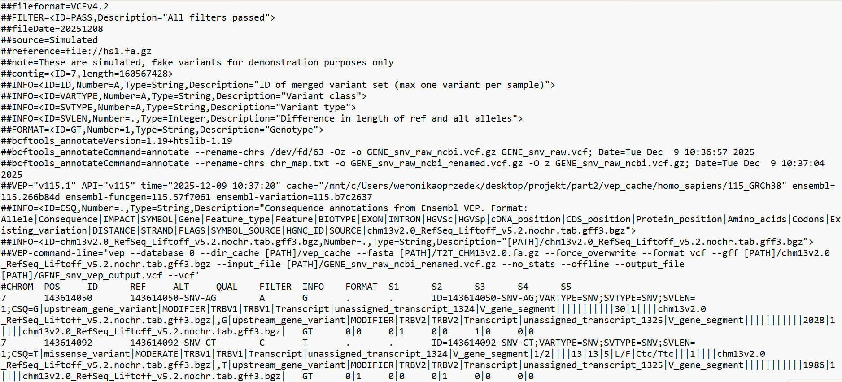Figure 4 part of example file GENE_snv_vep_output.vcf

2.4 Data preprocessing

2.4.1 Output
Data preprocessing generates the following core objects:
- locus - genomic coordinates of the selected genes (chromosome, start, end).
- sample_region - named list mapping each region to the samples belonging to it.
- region_colors - reproducible color palette for region groups.
- result - a variant × sample matrix containing final variant category assignments.
- result_long - long-format table summarizing variant, consequence, and sample-level calls.
- all_categories - vector listing the full set of VEP consequence categories observed.
- variant_hierarchy - full impact hierarchy used to prioritize variant consequences.
- variant_hierarchy_no_modifier - hierarchy excluding the “modifier” classes.
- variant_colors - named vector mapping each category to a consistent color.
- variant_palettes - named vector mapping each category to a consistent palette.

These objects are passed directly into downstream workflows.
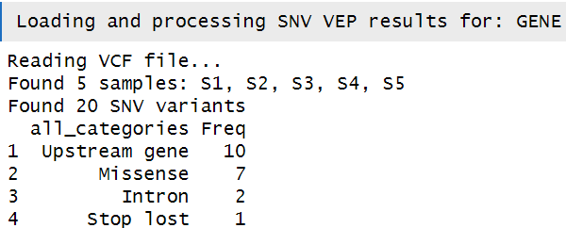
Figure 5 example printed messages

2.4.2 Steps
- Load metadata
- Reads gene coordinates using load_gene_information(), which extracts chromosome, start, and end positions from <GENE>.xlsx.
- Reads sample-to-region assignments using load_region_information() from SampleArea.xlsx, which returns:
  - sample_region - list of samples grouped by region
  - region_colors - mapping of regions to colors.
- Creates objects: variant_hierarchy, variant_hierarchy_no_modifier, variant_colors.

- Load and preprocess VEP-annotated variants
- VEP-annotated VCF files are parsed using VariantAnnotation, ensuring consistent handling of genotypes, ALT alleles, and INFO fields.
- The preprocessing functions (analyze_vep_snv_variants(), analyze_vep_indel_variants(), analyze_vep_sv_variants()) perform:
  - extraction of variant Position, REF, ALT, and sample genotypes,
  - parsing of the CSQ field to retrieve functional consequences,
  - mapping of consequences to the unified severity hierarchy,
  - construction of a variant × sample category matrix (result).
- For INDEL and SV only the INFO tag SVLEN is additionally extracted and stored.
- Variant loading only occurs when pipeline steps 2–5 are requested.

- Convert genotype data to long format
- The wide result matrix is converted to tidy long format.

- Report missing positions
- The pipeline counts how many variants have missing genomic coordinates.
- A warning is printed if missing values are detected. This step serves as a basic quality control check before visualization.

- Summarize variant category frequencies
- All VEP categories encountered in the gene are collected as all_categories.
- A table of category counts is printed, sorted by decreasing frequency.

2.4.3 Notes
- All variant consequence interpretation uses a uniform severity hierarchy based on Ensembl predictions. The full ordering from highest to lowest impact is: transcript ablation, splice acceptor, splice donor, stop gained, frameshift, stop lost, start lost, transcript amplification, feature elongation, feature truncation, missense, inframe insertion, inframe deletion, protein altering, splice region, incomplete terminal codon, start retained, stop retained, synonymous, coding sequence, UTR, mature miRNA variant, non-coding transcript exon, intron, NMD transcript, non-coding transcript, coding transcript, upstream gene, downstream gene, TF binding site, regulatory region, intergenic, sequence.
- Multi-consequence VEP annotations are split and assigned to the highest-impact category.
- Missing or malformed consequence entries are safely handled using csq_safe().
- Samples with no mutation for a given variant are encoded as NA, preserving the complete sample list.
- The pipeline preserves the gene(s) defined coordinate range(s) and excludes outside variants.

2.5 Step 1 - Variant burden heatmap

2.5.1 Input
Previously generated objects: locus, output_dir, sample_region, region_colors, gene_name.
Variant table (SNV / INDEL / SV) created from the raw VCF variant file. Required core columns:
- SNV: CHROM, POS, REF, ALT, INFO, sample columns
- INDEL/SV: CHROM, POS, REF, ALT, INFO, SVTYPE, SVLEN, sample columns

2.5.2 Output
Step 1 produces one heatmap showing:
- X-axis: genes
- Y-axis: samples grouped by regions
- Gradient color: log-transformed values of variant burden
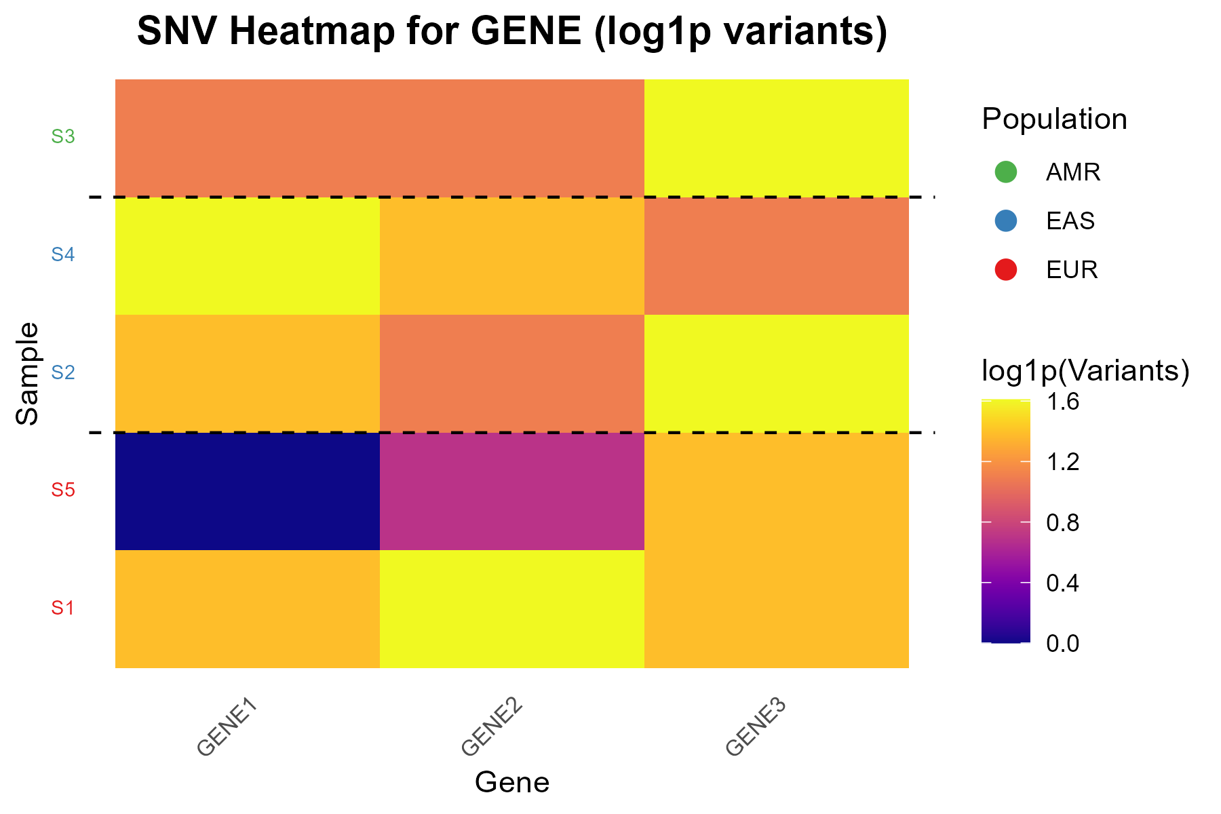
Figure 6 example snv_results/snv_heatmap_GENE.png

2.5.3 Steps
- Load VCF and standardize columns
- Metadata columns are kept minimal; remaining columns are treated as samples.

- Convert genotypes to allele counts
- Genotypes are converted into variant counts using the mapping in convert_genotype():
Genotype | Count
0|0, .|. | 0
0|1, 1|0, .|1, 1|. | 1
1|1 | 2
any other value | 0

- Assign variants to genes using genomic ranges
- Genes and variants are converted to GRanges.
- findOverlaps() is used to assign each variant to a gene.

- Compute variant burden per sample
- Per-gene sum of allele counts.
- Heatmap uses log1p(burden) to stabilize high values.

- Add region labels
- Samples are colored by the user-supplied region list and colors.

- Generate heatmap
- viridis::plasma palette,
- region-specific y-axis colors,
- dashed horizontal boundaries between regions,
- Save PNG with 300 dpi and dynamic width and height.

2.5.4 Notes
- Uses raw genotype information only, no VEP consequences.
- Log transformation: log1p() preserves zeros.
- INDEL and SV variants use span-based genomic ranges; insertions are always treated as 1 bp.

2.6 Step 2 - Bubble plot

2.6.1 Input
Previously generated objects: result_long, sample_region, locus, variant_palettes, min_size, max_size, output_dir, gene_name.

2.6.2 Output
This step summarizes the distribution of variant categories. Bubble plots visualize how frequently variants of specific categories occur across regions, normalized by sample counts within each region.
The pipeline produces one bubble plot per variant category, showing:
- X-axis: genes
- Y-axis: region groups
- Bubble size: proportion of samples in the region carrying a variant
- Bubble fill color: average number of mutations per sample (gradient)
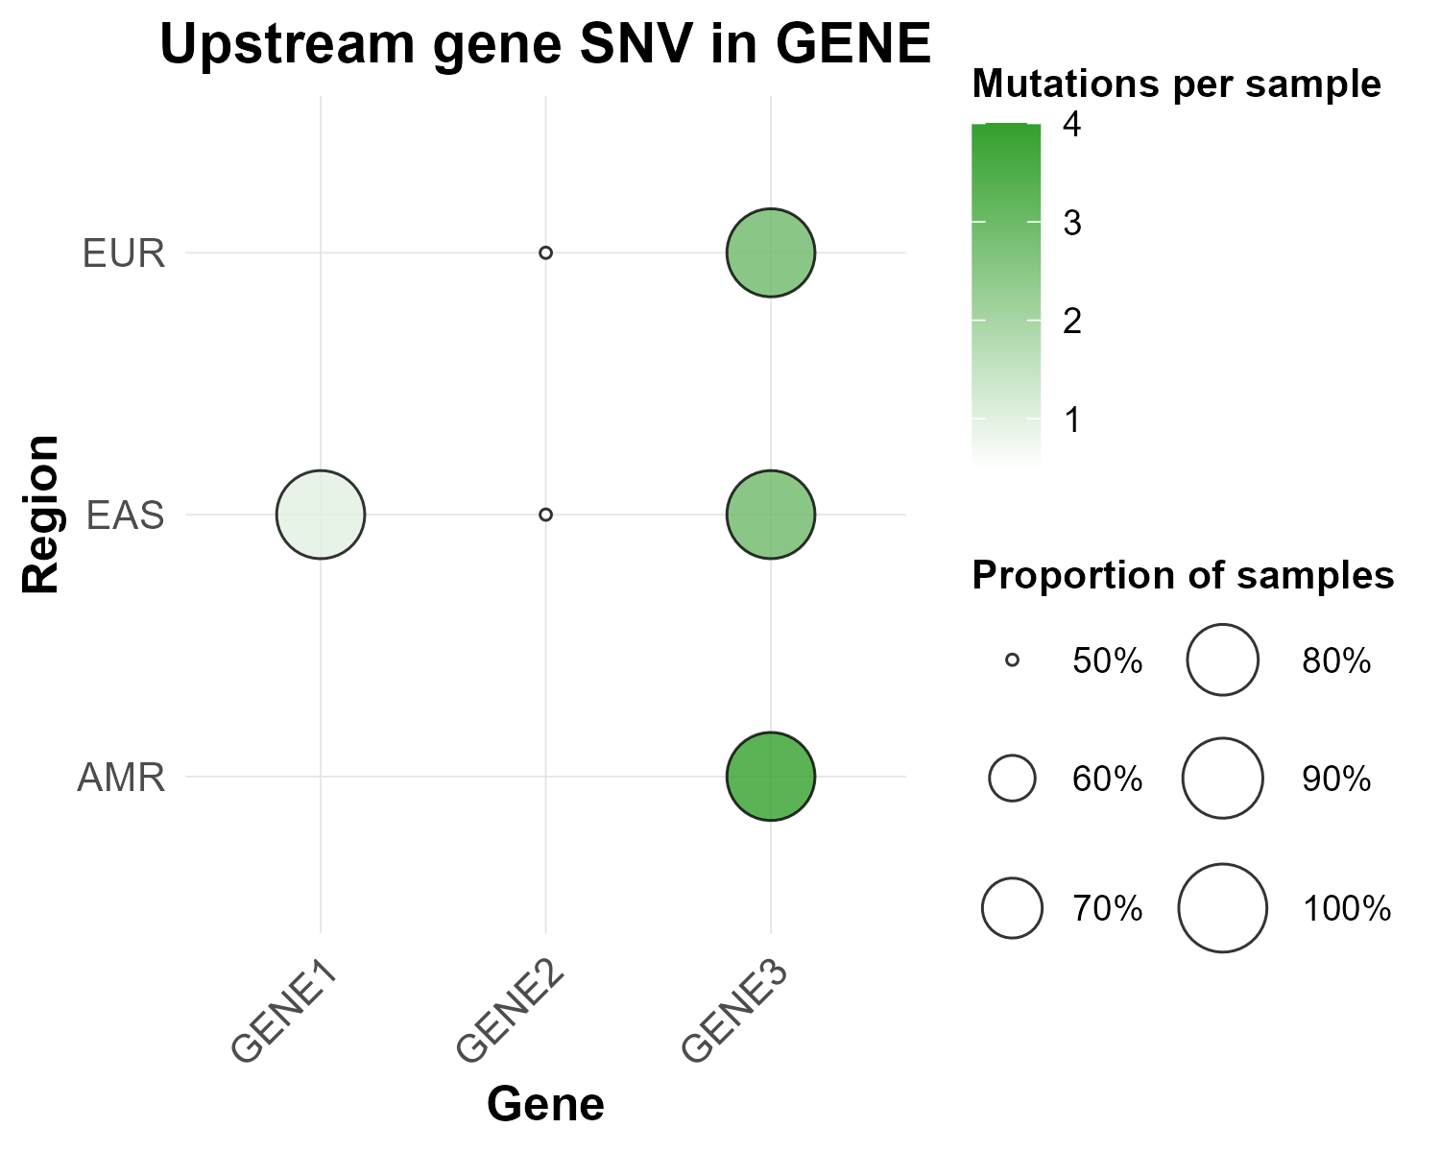
Figure 7 example snv_results/Upstream_gene_SNV_in_GENE.png

2.6.3 Steps
- Prepare gene annotations
- Standardize column names: gene, chromosome, start, end.
- Keep only rows matching the requested variant type.

- Assign variants to genes
- Use genomic ranges and findOverlaps or filtering by coordinates.

- Map samples to regions

- Summarize per gene × region × variant type
- mutated_samples — number of unique samples carrying a variant
- total_mutations — total number of variant occurrences
- proportion — mutated_samples / total_samples_in_region
- mutations_per_sample — total_mutations / total_samples_in_region

- Generate bubble plot
- Save PNG with 300 dpi and dynamic width and height.

2.6.4 Notes
- Bubble plots normalize variant counts per region, allowing cross-region comparison.
- INDEL and SV variants use span-based genomic ranges; insertions are always treated as 1 bp.

2.7 Step 3 - Dual-bubble comparison

2.7.1 Input
Previously generated objects: result_long, sample_region, locus, min_size, max_size, output_dir, gene_name.

2.7.2 Output
Dual-bubble plot PNG summarizing variant burden per gene and per region group:
- X-axis: genes
- Y-axis: regions split into two tracks:
  - SNV: nonsynonymous vs synonymous
  - INDEL: PTV (protein truncating variant) vs non-PTV
- Bubble size: proportion of samples in region carrying a variant
- Bubble fill color: normalized mutations per sample (gradient)
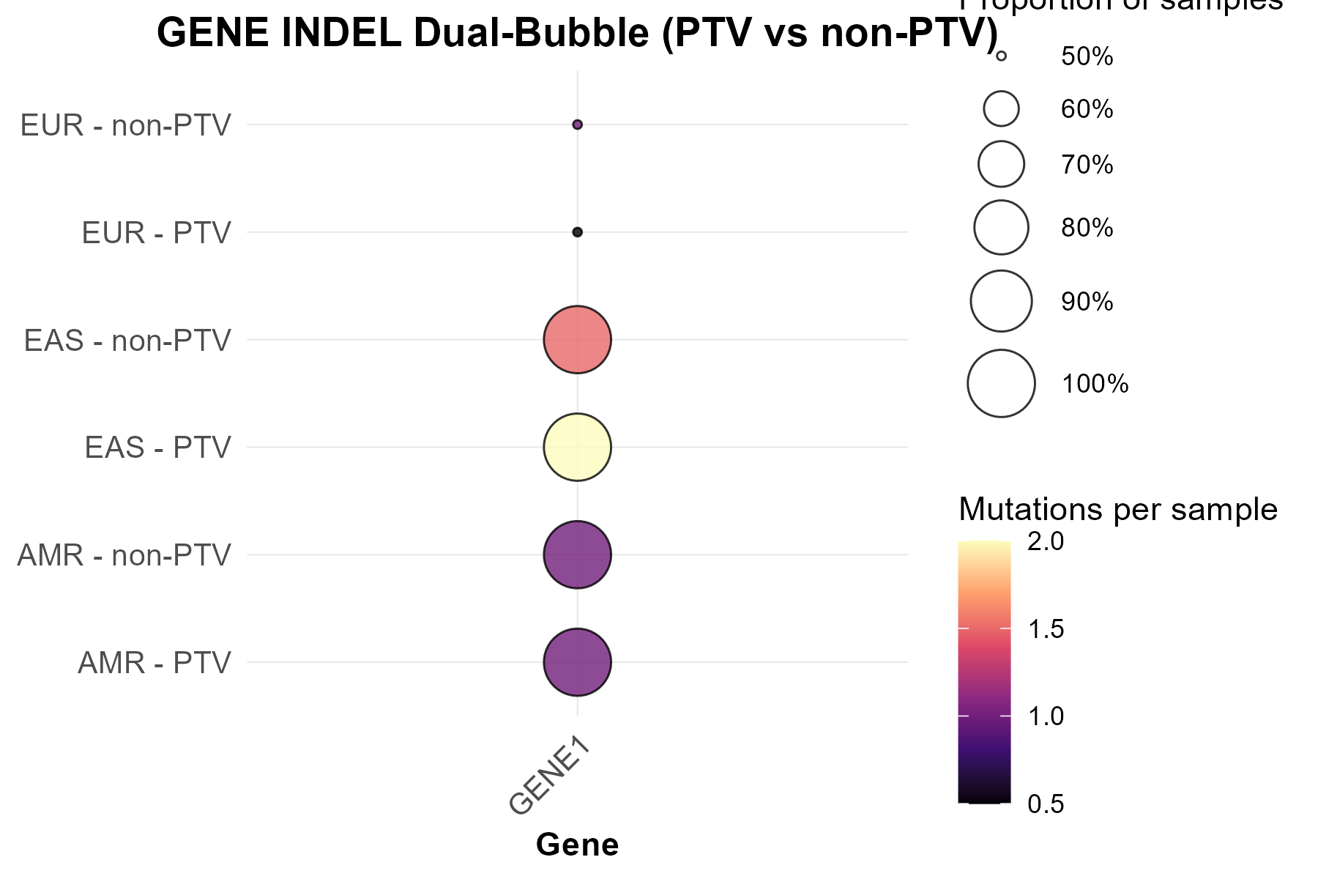
Figure 8 example indel_results/INDEL_Dual_Bubble_GENE.png

2.7.3 Steps
- Prepare gene coordinates
- Standardize column names: gene, chromosome, start, end.

- Process variants
- SNVs: categorize as nonsynonymous (missense, stop gained, stop lost, start lost) or synonymous (synonymous, stop retained).
- INDELs: categorize as PTV (frameshift, transcript ablation, stop gained, stop lost, start lost) or non-PTV using variant type hierarchy.

- Assign variants to genes
- Use genomic ranges and findOverlaps or filtering by coordinates.

- Map samples to regions

- Summarize per gene × region × category
- mutated_samples: number of unique samples with a variant.
- total_mutations: total variant occurrences.
- proportion: mutated_samples / total_samples_in_region.
- mutations_per_sample: total_mutations / total_samples_in_region.

- Generate bubble plot
- Save PNG with 300 dpi and dynamic width and height.

2.7.4 Notes
- Dual-bubble plots normalize variant counts per region, allowing cross-region comparison.
- INDEL and SV variants use span-based genomic ranges; insertions are always treated as 1 bp.

2.8 Steps 4&5 - Summary plots

2.8.1 Input
Previously generated objects: result, result_long, sample_region, region_colors, variant_colors, output_dir, gene_name, variant_types (optional):
- not provided → Step 4: full spectrum of VEP consequence categories,
- provided → Step 5: subset of high/moderate/low impact categories.

2.8.2 Output
This module generates a set of summary visualizations. It can operate in two complementary modes, depending on which pipeline step is executed:
- Step 4 - Full summary: all variant types present in the VEP-annotated data are included.
- Step 5 - Focused summary: Visualization restricted to high-, moderate-, and low-impact variants.

- Main Variant Track Plot (<GENE>_summary_main.png)
- X-axis: genomic positions
- Y-axis: samples grouped by regions
- Tile fill: variant type
- Region boundaries shown as dashed horizontal lines
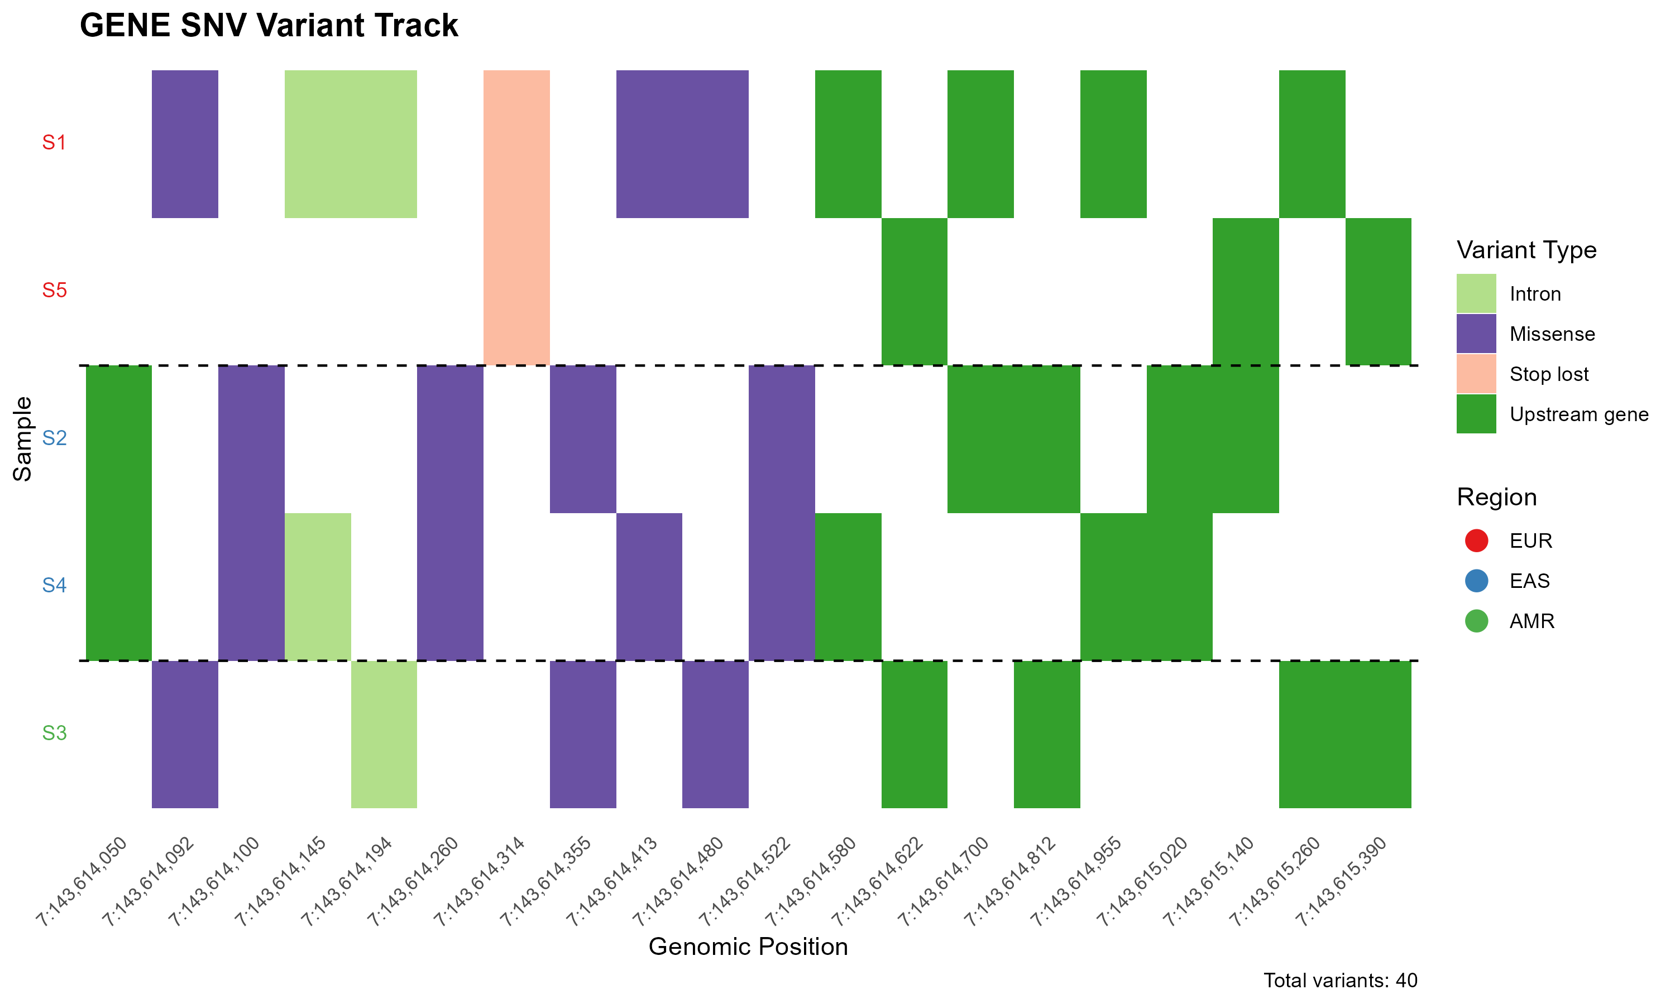
Figure 9 example snv_results/GENE_summary_main.png

- Per-sample Variant Count Plot (<GENE>_summary_samples.png)
- X-axis: samples grouped by regions
- Y-axis: variant count
- Color Fill: variant type
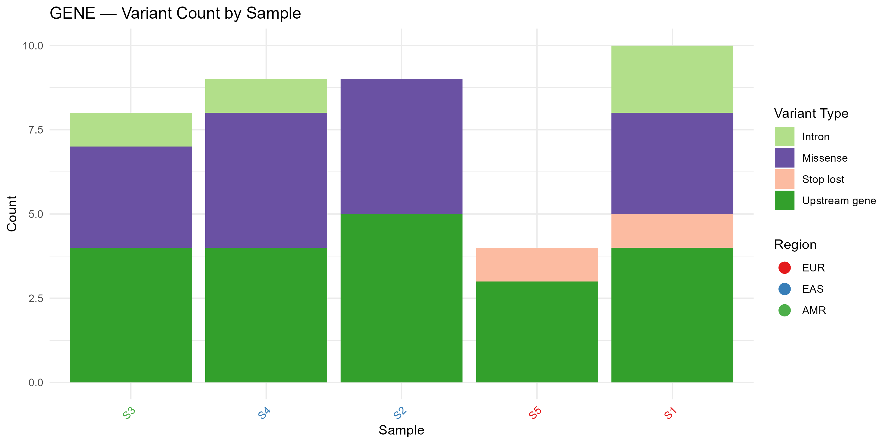
Figure 10 example snv_results/GENE_summary_samples.png

- Variant-Type Distribution Plot (<GENE>_summary_types.png)
- X-axis: variant type
- Y-axis: variant count
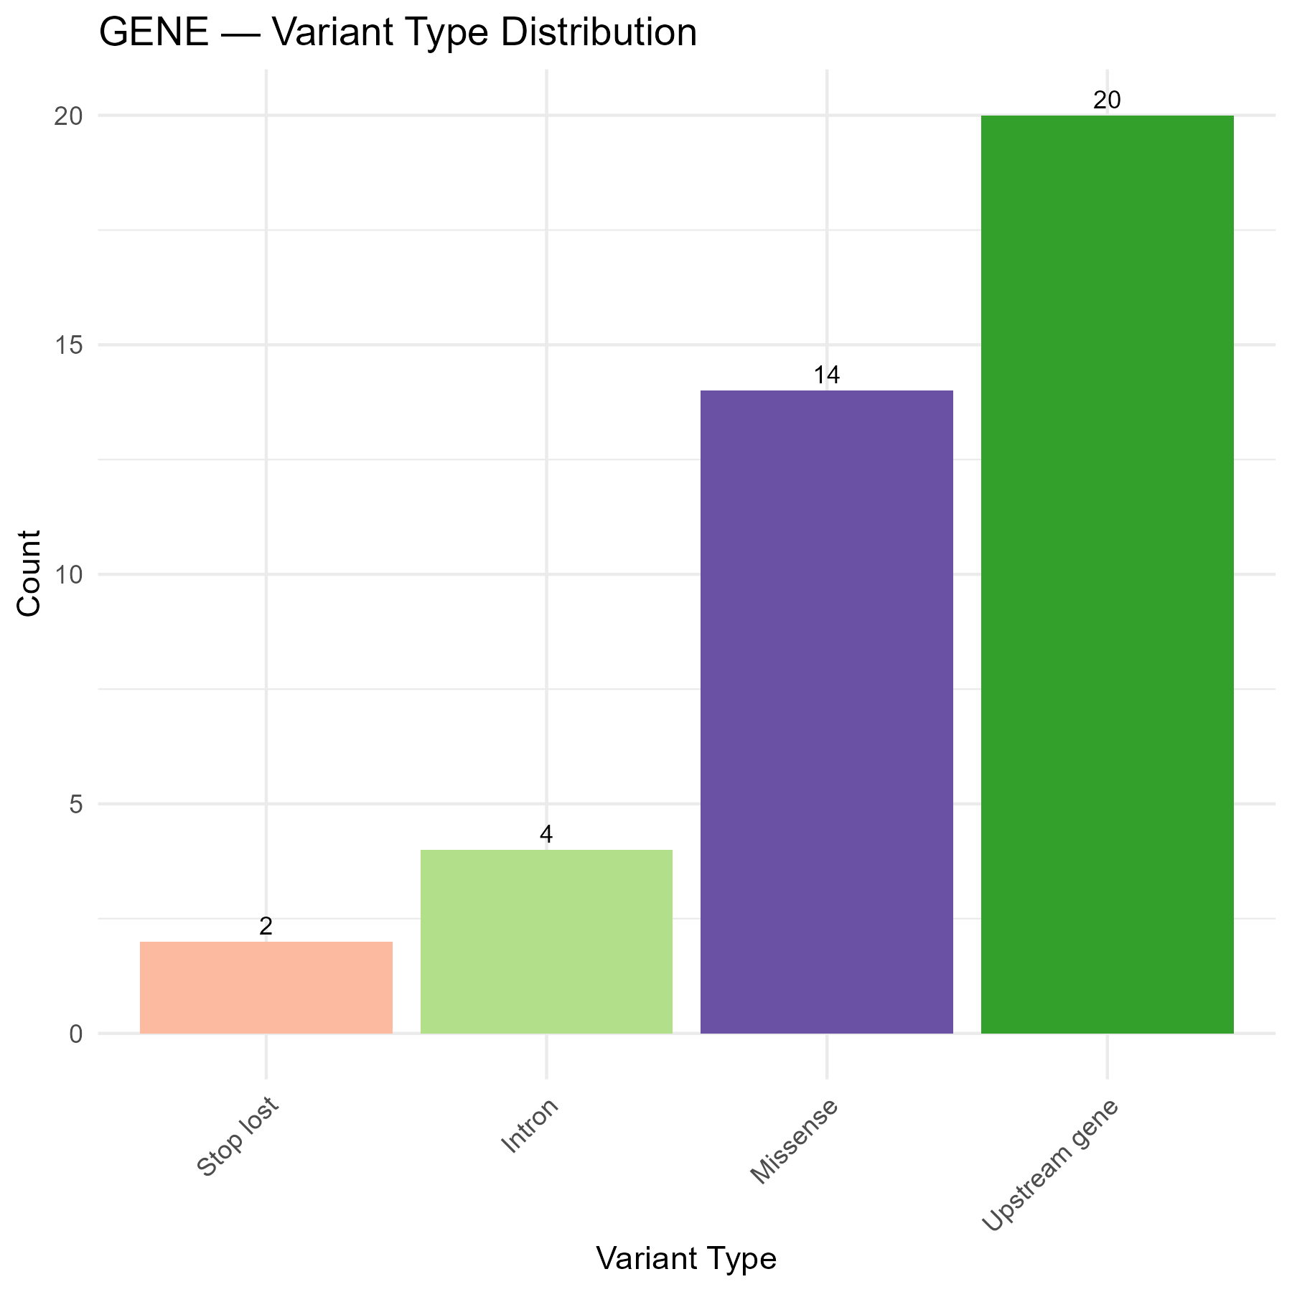
Figure 11 example snv_results/GENE_summary_types.png

- Region-Level Summary Plot (<GENE>_summary_regions.png)
- X-axis: regions
- Y-axis: mean variant count per sample
- Color Fill: variant type
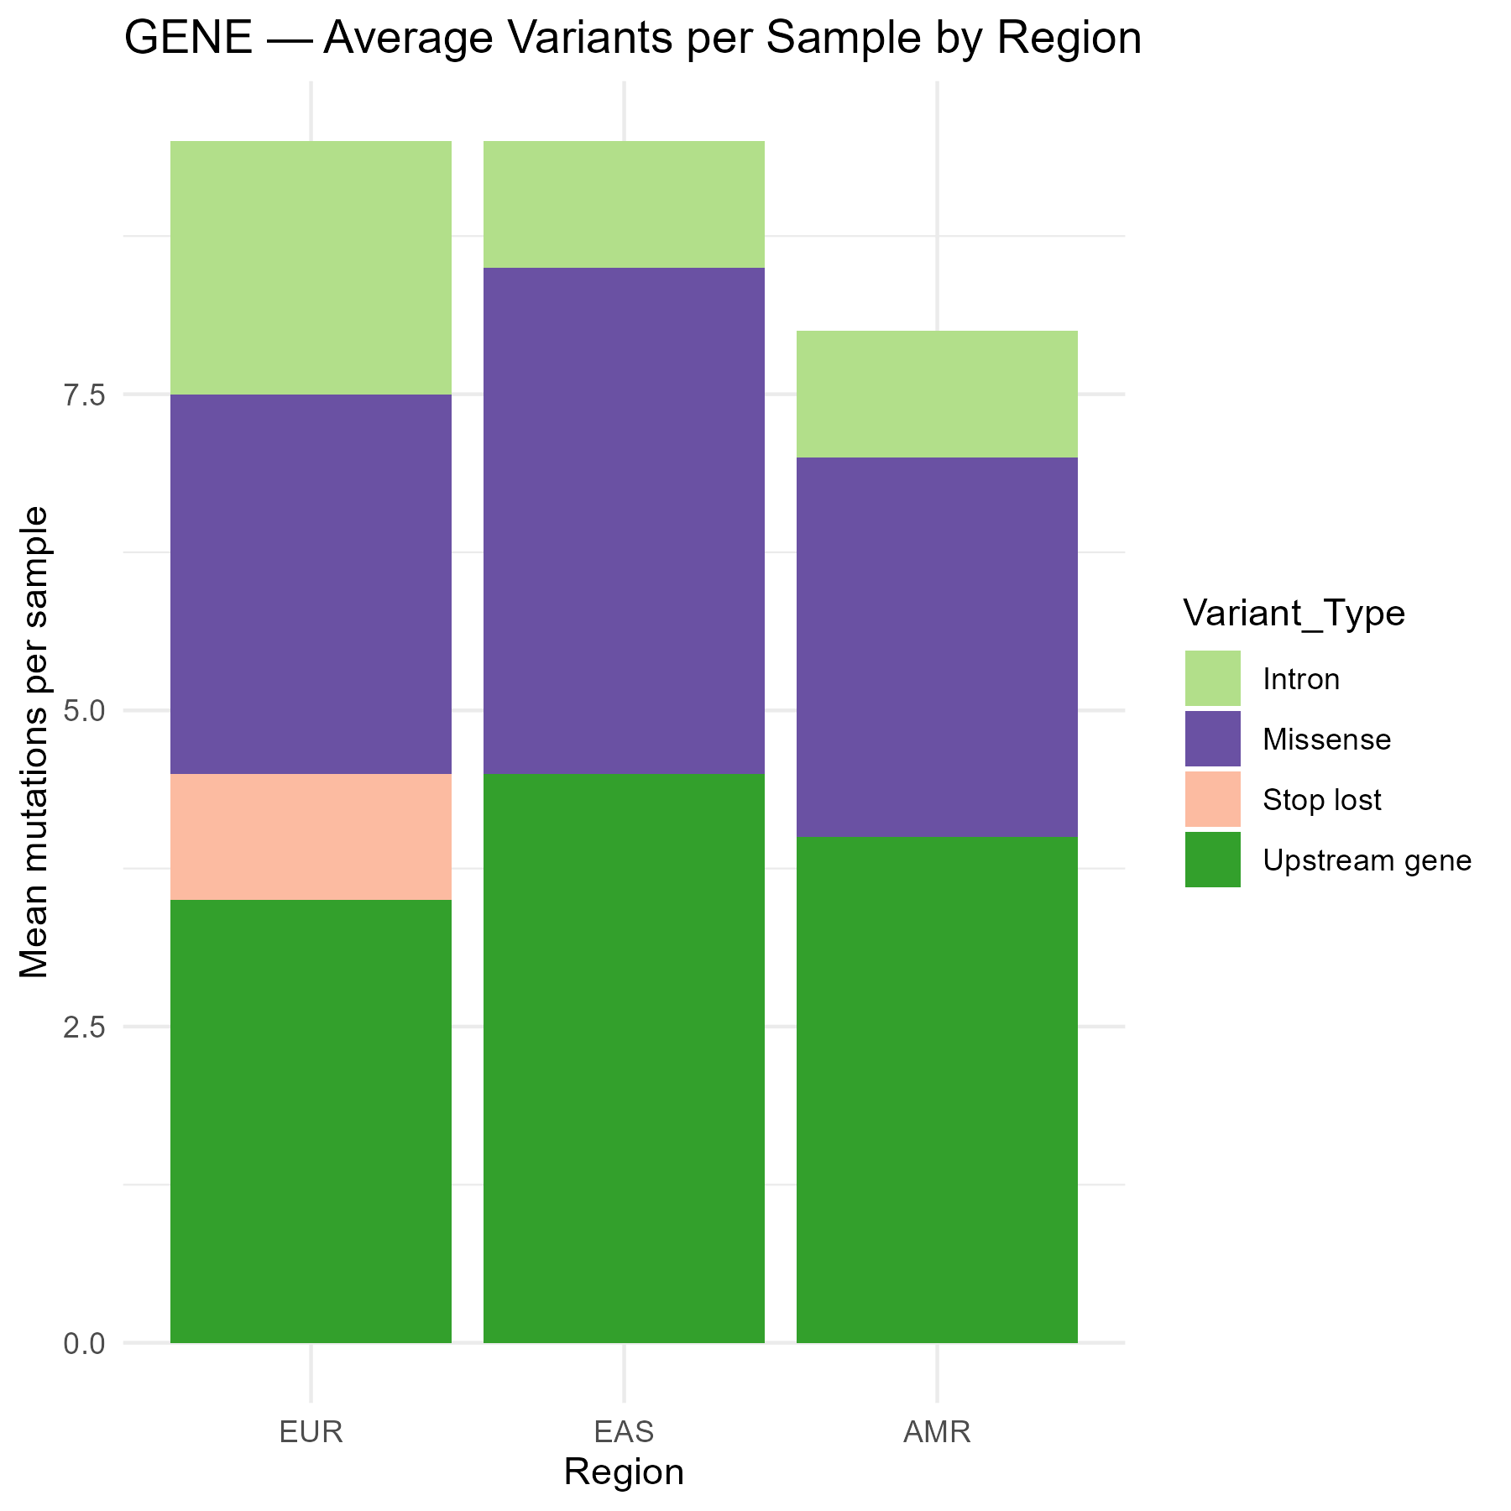
Figure 12 example snv_results/GENE_summary_regions.png

Step 5 produces files with suffix _summary_focus, ensuring that both analyses can coexist.

2.8.3 Steps
- Prepare input data
- Extract chromosome and numeric position.
- Filter by selected variant types if provided.

- Map samples to regions

- Arrange genomic positions in natural numeric order

- Generate the variants track plot
- Add dashed horizontal separators between regions.

- Generate per-sample summary plot
- Count variants per sample × variant type.

- Generate variant-type distribution plot
- Count total occurrences per variant type.
- Create a bar plot with counts labeled above columns.

- Generate region-level summary
- Compute mean variant count per sample for each region and variant type.

- Save plots
- Save PNGs with 300 dpi and dynamic width and height.

2.8.4 Notes
- Automatic axis label thinning prevents overcrowding in track plot when the number of unique variant positions is large.
- The focused summary uses consistent region and sample ordering to make plots directly comparable to the full summary.

2.9 Step 6 - Track map

2.9.1 Input
Previously generated objects: locus, sample_region, region_colors, indel_colors / sv_colors, gene_name, point_alpha, output_dir.
Variant table (INDEL / SV) created from the raw VCF variant file. Required core columns: CHROM, POS, REF, ALT, INFO, SVTYPE, SVLEN, sample columns.

2.9.2 Output
This module generates a genome-aligned track map showing the exact genomic positions of INDEL and SV events for every sample. Each event is plotted as a horizontal segment (start–end span), colored by variant type (e.g., DEL/INS/INV). The plot provides a compact overview of structural variation across the gene locus.
Each plot contains:
- X-axis: genomic positions
- Y-axis: samples grouped by regions
- Horizontal segments representing variant spans
- Gene model drawn above the variant tracks

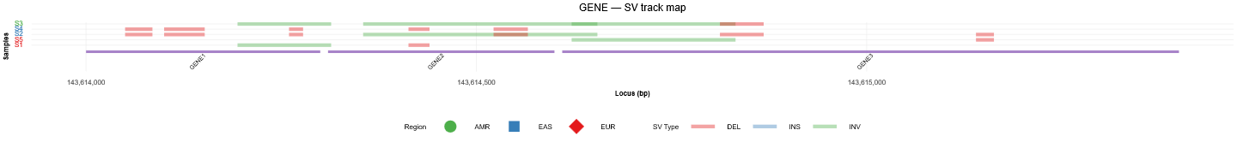
Figure 13 example sv_results/GENE_sv_track.svg

2.9.3 Steps
- Load VCF and standardize columns
- Metadata columns are kept minimal; remaining columns are treated as samples.
- Extract length information

- Map samples to regions

- Restrict to gene locus
- Keep only variants within gene(s) range.

- Compute segment start/end

- Generate track plot

- Save plot
- Save SVGs with dynamic height.

2.9.4 Notes
- Uses raw genotype information only, no VEP consequences.
- Segment length directly reflects genomic span of each event, with INS variants drawn as points (segment of length 1 bp).

3. Combined analysis
The Topology Encoder module generates a unique binary code for each leaf node in a phylogenetic tree, based on the tree's topology. This encoding provides a standardized representation of the tree structure, which is essential for downstream evolutionary pattern analyses.

3.1 Example Pipeline Execution
Running the pipeline with all default parameters:

Rscript ./combined.r
The command executes the full workflow on the provided example data.

3.2 Command-line Arguments
Argument | Description | Default
-g, --gene | Gene basename used for analysis and file matching | "GENE"
-i,  --input_dir | Input directory containing all required files and subdirectories | "."(current directory)
-o,  --output_dir | Directory to store generated plots | "combined_results"
-s,  --step | Workflow steps to run:  1 = Variability score calculation  2 = Comparison with evolutionary metrics  3 = Haplotype analysis  Step 2 requires Step 1 | "1,2,3"
--msa_dir | Directory containing multiple sequence alignments (MSA) and evolutionary matrices used in Step 2. Distance and dN–dS matrices are optional, the analysis runs if at least one of them is provided. | "msa"
--variant_missing_threshold | Maximum allowed proportion of missing genotype data per variant. Variants exceeding this threshold are removed before analysis. | 0.5
--sample_missing_threshold | Maximum allowed proportion of missing genotype data per sample. Samples exceeding this threshold are removed before analysis. | 0.7
--use_length_factor | If TRUE, variant contribution to variability scores is weighted by variant length (relevant for INDELs and SVs). | TRUE
--normalize_by_samples | If TRUE, variability scores are normalized by the number of available samples per region or gene. | TRUE
--detailed | If TRUE, generates detailed regression summaries and diagnostic outputs for evolutionary metrics analyses. | FALSE

3.2 Input
The combined analysis module requires gene-specific metadata, variant call files, and evolutionary data. Input files are read from the directories specified by --input_dir and --msa_dir, following a standardized directory structure.
Variant and Metadata Input
The directory specified by --input_dir must contain gene locus information, sample-to-region metadata, and VCF files for SNV, INDEL, and SV analyses. Expected directory structure:
<input_dir>/
<GENE>.xlsx
SampleArea.xlsx
snv/
<GENE>_snv_vep_output.vcf
<GENE>_snv_raw.vcf
indel/
<GENE>_indel_vep_output.vcf
<GENE>_indel_raw.vcf
sv/
<GENE>_sv_vep_output.vcf
<GENE>_sv_raw.vcf

The structure and required files in --input_dir are described in Section 2.2.1–2.2.4.

Evolutionary Input (Step 2 only)
The directory specified by --msa_dir contains multiple sequence alignments (MSA) and evolutionary metrics, including pairwise distance matrices and/or pairwise dN–dS matrices. The expected --msa_dir directory structure is:

<msa_dir>/
<GENE>*.fas / <GENE>*.fasta
distance/
*.txt
dN-dS/
*.txt

Either one or both evolutionary metrics subdirectories may be present:
- If only distance/ is provided, distance-based metrics are computed.
- If only dn-ds/ is provided, selection-based metrics are computed.
- If both are provided, both analyses are performed and compared.

3.2.1 FASTA sequence files
One or more FASTA files (<GENE>*.fas / <GENE>*.fasta) containing multiple sequences alignments, nucleotide or amino acid sequences for the genes of interest. The pipeline does not rely on alignment content or sequence length. Only sequence identifiers are used to define homologous relationships between species.
Each FASTA file must contain:
- one or more human sequence ending with _Hsa (e.g. GENE1_Hsa),
- one or more non-human homologous sequences:

Sequence inclusion rules:
- The gene prefix is inferred from the human sequence name.
- Any sequence starting with this prefix followed by _, -, −, or no separator is accepted (e.g. GENE1_Mmu, GENE1-Ptr, GENE12),
- Sequences starting with a different prefix (e.g. GENE10_Mmu) are excluded.
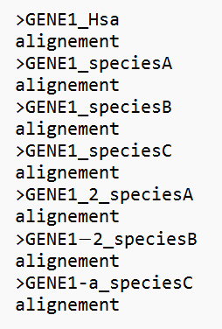
Figure 14 example file GENE_A.fas

3.2.2 Pairwise distance matrices
One or more text files containing pairwise evolutionary distance matrices corresponding to the provided FASTA files.

Requirements:
- Matrix row and column names must match the sequence identifiers in the corresponding FASTA file.
- Matrices must be square (N × N).
- Matrices may be fully filled or triangular (upper or lower).
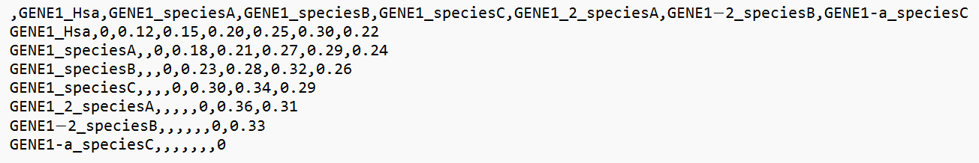
Figure 15 example file distance/GENE_A.txt

3.2.3 Pairwise dN-dS matrices
One or more text files containing pairwise dN–dS estimates corresponding to the provided FASTA files.
Requirements:
- Matrix row and column names must match the sequence identifiers in the corresponding FASTA file.
- Matrices must be square (N × N).
- The matrix is expected to be triangular:
  - the upper triangular part contains dN–dS estimates,
  - the lower triangular part contains the corresponding p-values.
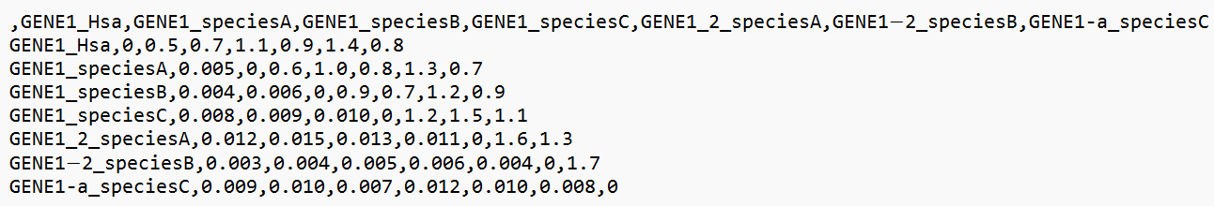
Figure 16 example file dn-ds/GENE_A.txt

3.3 Data preprocessing

3.3.1 Output
This step prepares all variant classes (SNVs, INDELs, and SVs) for downstream analysis using a unified logic and shared metadata. Preprocessing is performed separately for each variant type. Data preprocessing generates the following core objects:
- locus - genomic coordinates of the selected genes (chromosome, start, end).
- sample_region - named list mapping each region to the samples belonging to it.
- region_colors - reproducible color palette for region groups.
- variant_hierarchy - full impact hierarchy used to prioritize variant consequences.
- snv_final - SNV table containing per-sample variant information within the defined gene locus.
- indel_final - INDEL table containing per-sample insertion/deletion information within the defined gene locus.
- sv_final - structural variant table containing per-sample SV information within the defined gene locus.
- total_samples_snv, total_samples_indel, total_samples_sv - number of samples per variant class
Each *_final table includes variant identifiers, sample IDs, genotype information, allele counts, missingness flags, and functional consequence categories derived from VEP.

3.3.2 Steps
- Load metadata
- Reads gene coordinates using load_gene_information(), which extracts chromosome, start, and end positions from <GENE>.xlsx.
- Reads sample-to-region assignments using load_region_information() from SampleArea.xlsx, which returns:
  - sample_region - list of samples grouped by region,
  - region_colors - mapping of regions to colors.
- variant_hierarchy object defining consequence severity is initialized.

- Load and preprocess VEP-annotated variants
SNVs, INDELs, and SVs are processed independently using variant-type–specific functions (process_snv_vcf(), process_indel_vcf(), process_sv_vcf()), but follow the same logic:
- VEP-annotated VCF files are parsed using VariantAnnotation, ensuring consistent handling of genotypes, ALT alleles, and INFO fields.
- Genotypes are converted to long format (variant × sample).
- Variant identifiers are constructed using chromosome, position, reference, and alternate alleles.
- Filtering
- Samples with missing genotype rates exceeding the defined threshold are excluded.
- Variants with missing genotype rates exceeding the defined threshold are excluded.
- Homozygous reference genotypes and partially missing genotype calls are removed.
- Only variants overlapping the defined gene locus are retained.
- Functional consequence annotation
- Consequences are mapped to a unified severity hierarchy.

3.3.3 Notes
- All variant consequence interpretation uses a uniform severity hierarchy based on Ensembl predictions. The full ordering from highest to lowest impact is: transcript ablation, splice acceptor, splice donor, stop gained, frameshift, stop lost, start lost, transcript amplification, feature elongation, feature truncation, missense, inframe insertion, inframe deletion, protein altering, splice region, incomplete terminal codon, start retained, stop retained, synonymous, coding sequence, UTR, mature miRNA variant, non-coding transcript exon, intron, NMD transcript, non-coding transcript, coding transcript, upstream gene, downstream gene, TF binding site, regulatory region, intergenic, sequence.
- Multi-consequence VEP annotations are split and assigned to the highest-impact category.
- Missing or malformed consequence entries are safely handled using csq_safe().
- Samples with no mutation for a given variant are encoded as NA, preserving the complete sample list.

3.4 Step 1 - Variability score
Step 1 quantifies gene-level variability by integrating single-nucleotide variants (SNVs), insertions/deletions (INDELs), and structural variants (SVs) into a unified, normalized variability score. The score reflects both the functional impact and allelic burden of observed variants, adjusted for sample availability and gene length.

3.4.1 Input
Previously generated objects: locus, snv_final, indel_final, sv_final, total_samples_snv, total_samples_indel, total_samples_sv, use_length_factor, normalize_by_samples, output_dir, gene_name

3.4.2 Output
A gene-level summary table (gene_scores) containing:
- gene – gene identifier.
- Start, End – genomic coordinates.
- total_contribution – cumulative variability score across all variant types.
- n_variants – number of unique variants observed.
- n_samples – number of samples with at least one variant.
- total_contribution_len – variability score normalized by gene length (per base pair).

The following plots are generated and saved to <output_dir>/score/:

- Histogram of normalized variability scores (<GENE>_distribution_log.png):
- X-axis: log(1 + variation / bp)
- Y-axis: gene count
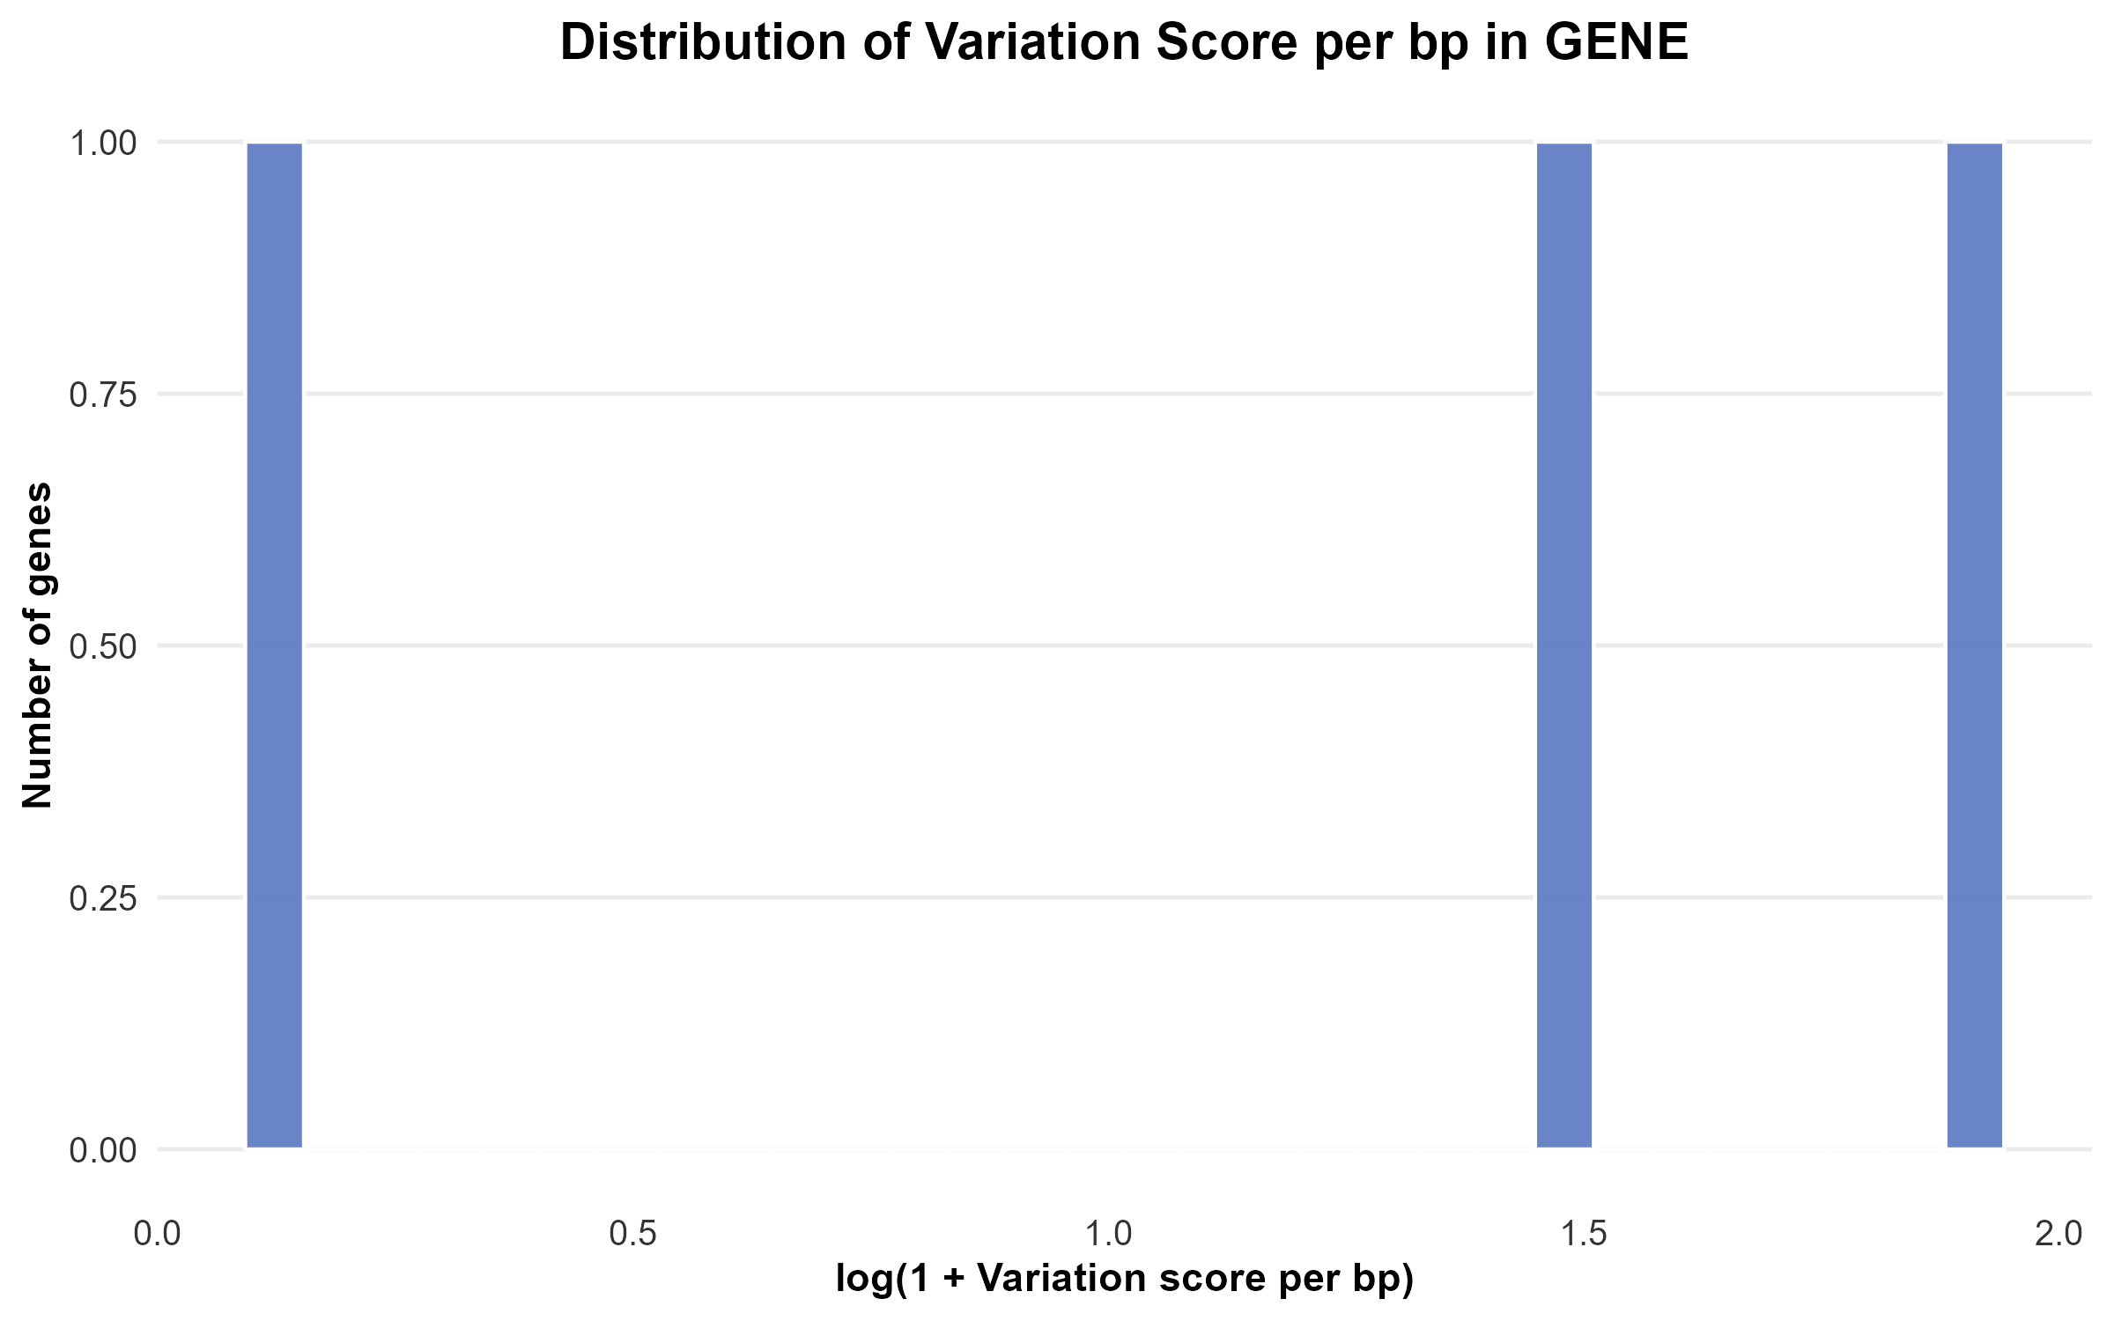
Figure 17 example GENE_distribution_log.png

- Bar plot of the top 20 most variable genes (<GENE>_top20_log.png)
- X-axis: gene name
- Y-axis: log(1 + variation / bp)

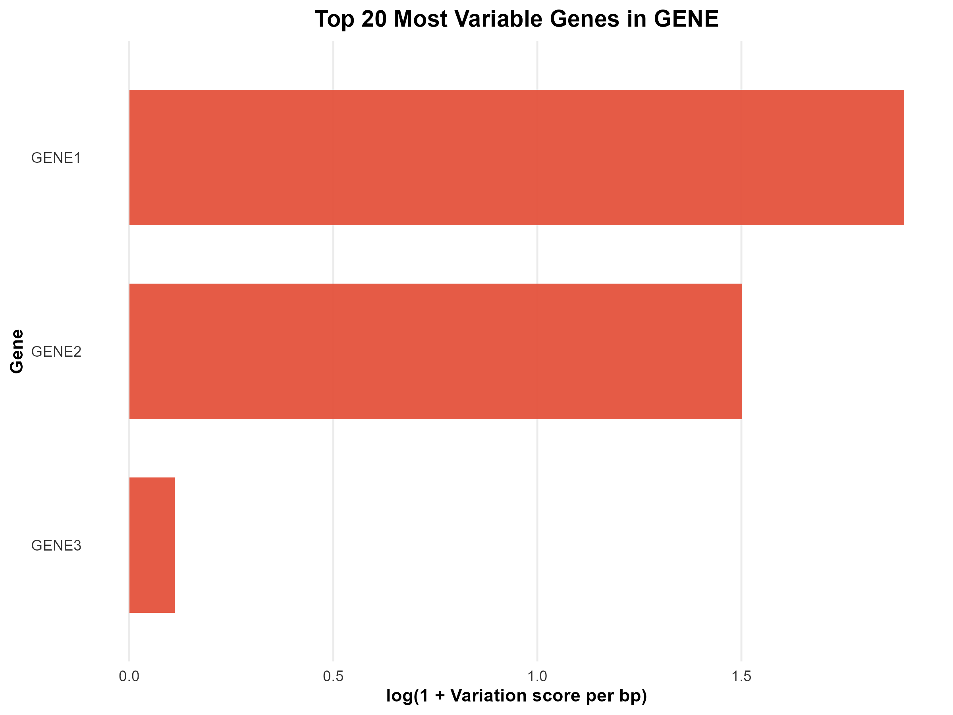
Figure 18 example GENE_top20_log.png

- Scatter plot of total variability versus gene length (<GENE>_length_correlation_log.png)
- X-axis: log(1 + gene length)
- Y-axis: log(1 + total variation)

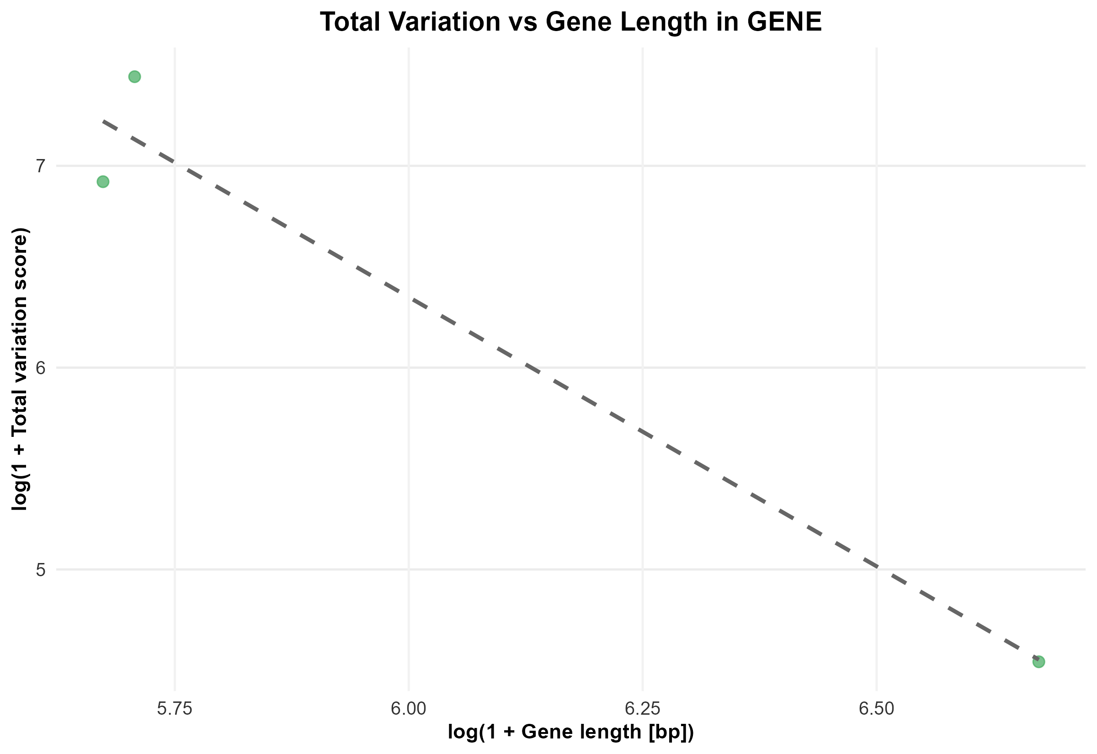
Figure 19 example GENE_length_correlation_log.png

- Ranked gene variability score plot (<GENE>_log.png)
- X-axis: gene name
- Y-axis: log(1 + variation / bp)
- Order: ascending score
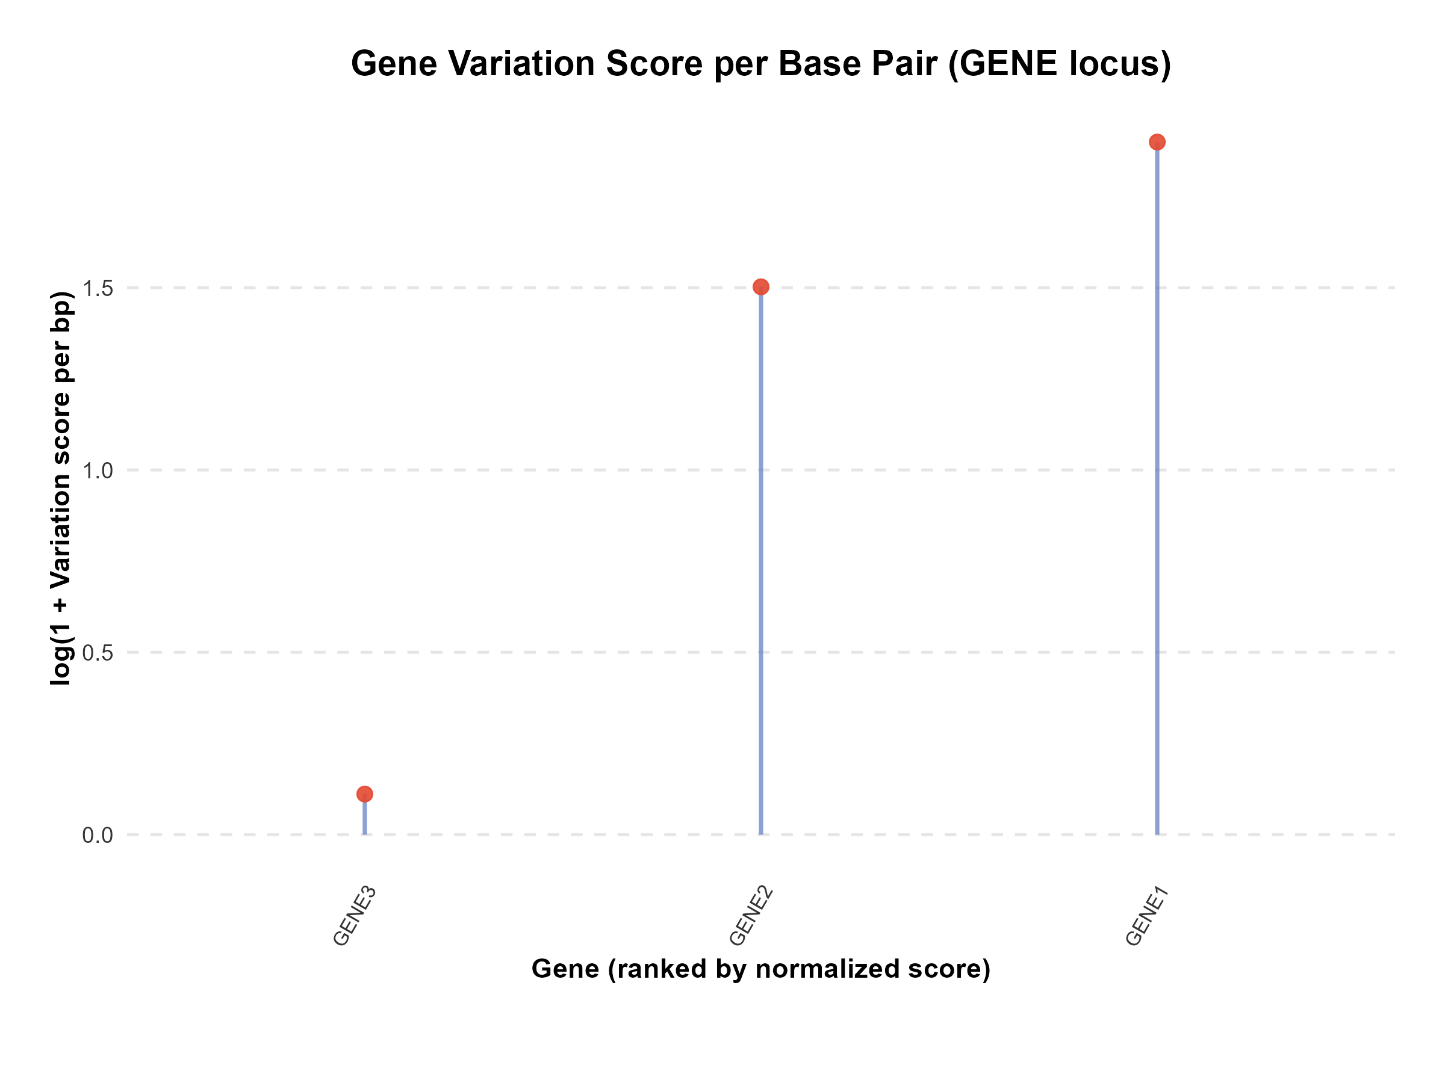
Figure 20 example GENE_log.png

3.4.3 Steps
- Variant integration
- All variant classes are combined into a single long-format table, retaining variant type labels.

- Functional weighting
- Each variant is assigned a severity weight based on its predicted functional consequence.
- Weights follow a predefined hierarchy derived from Ensembl consequence annotations.
Variant Type |  | Transcript ablation |  | Splice acceptor |  | Splice donor |  | Stop gained |  | Frameshift |  | Stop lost |  | Start lost |  | Transcript amplification
Weight |  | 3 |  | 2.6 |  | 2.6 |  | 2.5 |  | 2.5 |  | 2.2 |  | 2.2 |  | 2
Variant Type |  | Feature elongation |  | Feature truncation |  | Missense |  | Inframe insertion |  | Inframe deletion |  | Protein altering |  | Splice region |  | Incomplete terminal codon
Weight |  | 2 |  | 2 |  | 1.8 |  | 1.6 |  | 1.6 |  | 1.6 |  | 1.5 |  | 1
Variant Type |  | Start retained |  | Stop retained |  | Synonymous |  | Coding sequence |  | UTR |  | Mature miRNA variant |  | Non-coding transcript exon |  | Intron
Weight |  | 0.8 |  | 0.8 |  | 0.5 |  | 0.4 |  | 0.3 |  | 0.3 |  | 0.25 |  | 0.2
Variant Type | NMD transcript |  | Non-coding transcript |  | Coding transcript |  | Upstream gene |  | Downstream gene |  | TF binding site |  | Regulatory region |  | Intergenic |  | Sequence
Weight | 0.25 |  | 0.25 |  | 0.25 |  | 0.15 |  | 0.15 |  | 0.3 |  | 0.25 |  | 0.1 |  | 0.1

- Allelic contribution
- Variant contributions are computed as:
contribution = severity_weight × allele_count × length_factor
- For SVs and INDELs, an optional length-based scaling factor is applied:
length_factor = 1 + min(log10(|SVLEN| + 1), 2)

- Sample normalization
- Contributions are optionally normalized by the number of samples contributing data for each variant class (SNV, INDEL, SV), enabling comparability across datasets with unequal sample availability.

- Gene-level aggregation
- Variant-level contributions are summed per gene.
- The total score is optionally normalized by gene length to obtain a per–base pair variability metric.

- Visualization
- Gene-level scores are visualized using multiple complementary plots to assess distribution, ranking, and gene-length dependency.

3.4.4 Notes
- The variability score represents mutational burden, not evolutionary conservation; higher values indicate greater observed variability.
- Log-transformed values (log1p) are used exclusively for visualization; all calculations are performed on linear scales.
- Genes with no detected variants are retained and assigned a variability score of zero.

3.5 Step 2 - Comparison with evolutionary metrics
Step 2 relates human population–level gene variability to evolutionary metrics metrics derived from cross-species sequence comparisons. Gene-level variability scores obtained in Step 1 are compared with evolutionary distances and/or dN–dS estimates calculated from multiple sequence alignment–based matrices. This step enables the identification of genes that are highly variable in human populations despite evolutionary constraint, or conversely conserved in humans but divergent across species.

3.5.1 Input
Previously generated objects: msa_dir, gene_scores, output_dir, gene_name, detailed

3.5.2 Output
Merged gene-level table combining human variability and evolutionary metrics, containing:
- gene – gene identifier
- total_contribution_len – normalized human variability score
- mean_distance, median_distance – mean and median evolutionary distance to non-human homologs
- mean_dnds, median_dnds – mean and median dN–dS values (FDR-adjusted)
- n_compared – number of non-human homologs compared
- matched_genes – list of homologous sequences used for comparison

The following plots are generated and saved to <output_dir>/compare/:
- Distribution histograms of variability, dN–dS, and/or distance (<GENE>_hist_score.png, <GENE>_hist_dnds.png, <GENE>_hist_dist.png)
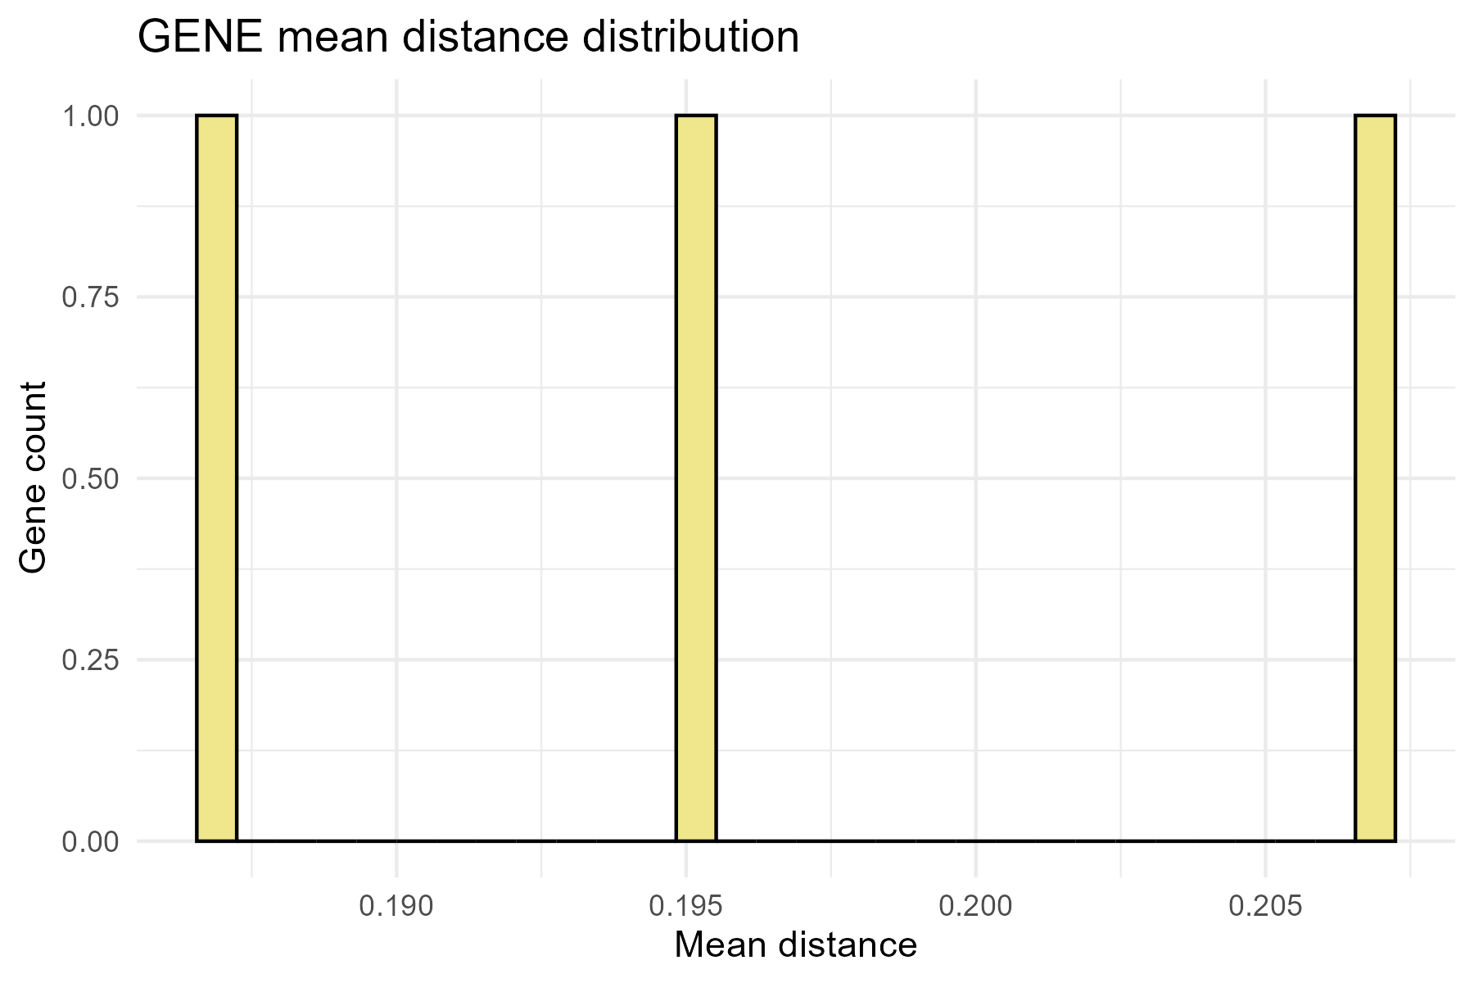
Figure 21 example GENE_hist_dist.png

- Scatter plots comparing human variability with evolutionary metrics (<GENE>_dnds.png, <GENE>_dist.png)
- Scale: squeezed z-scores
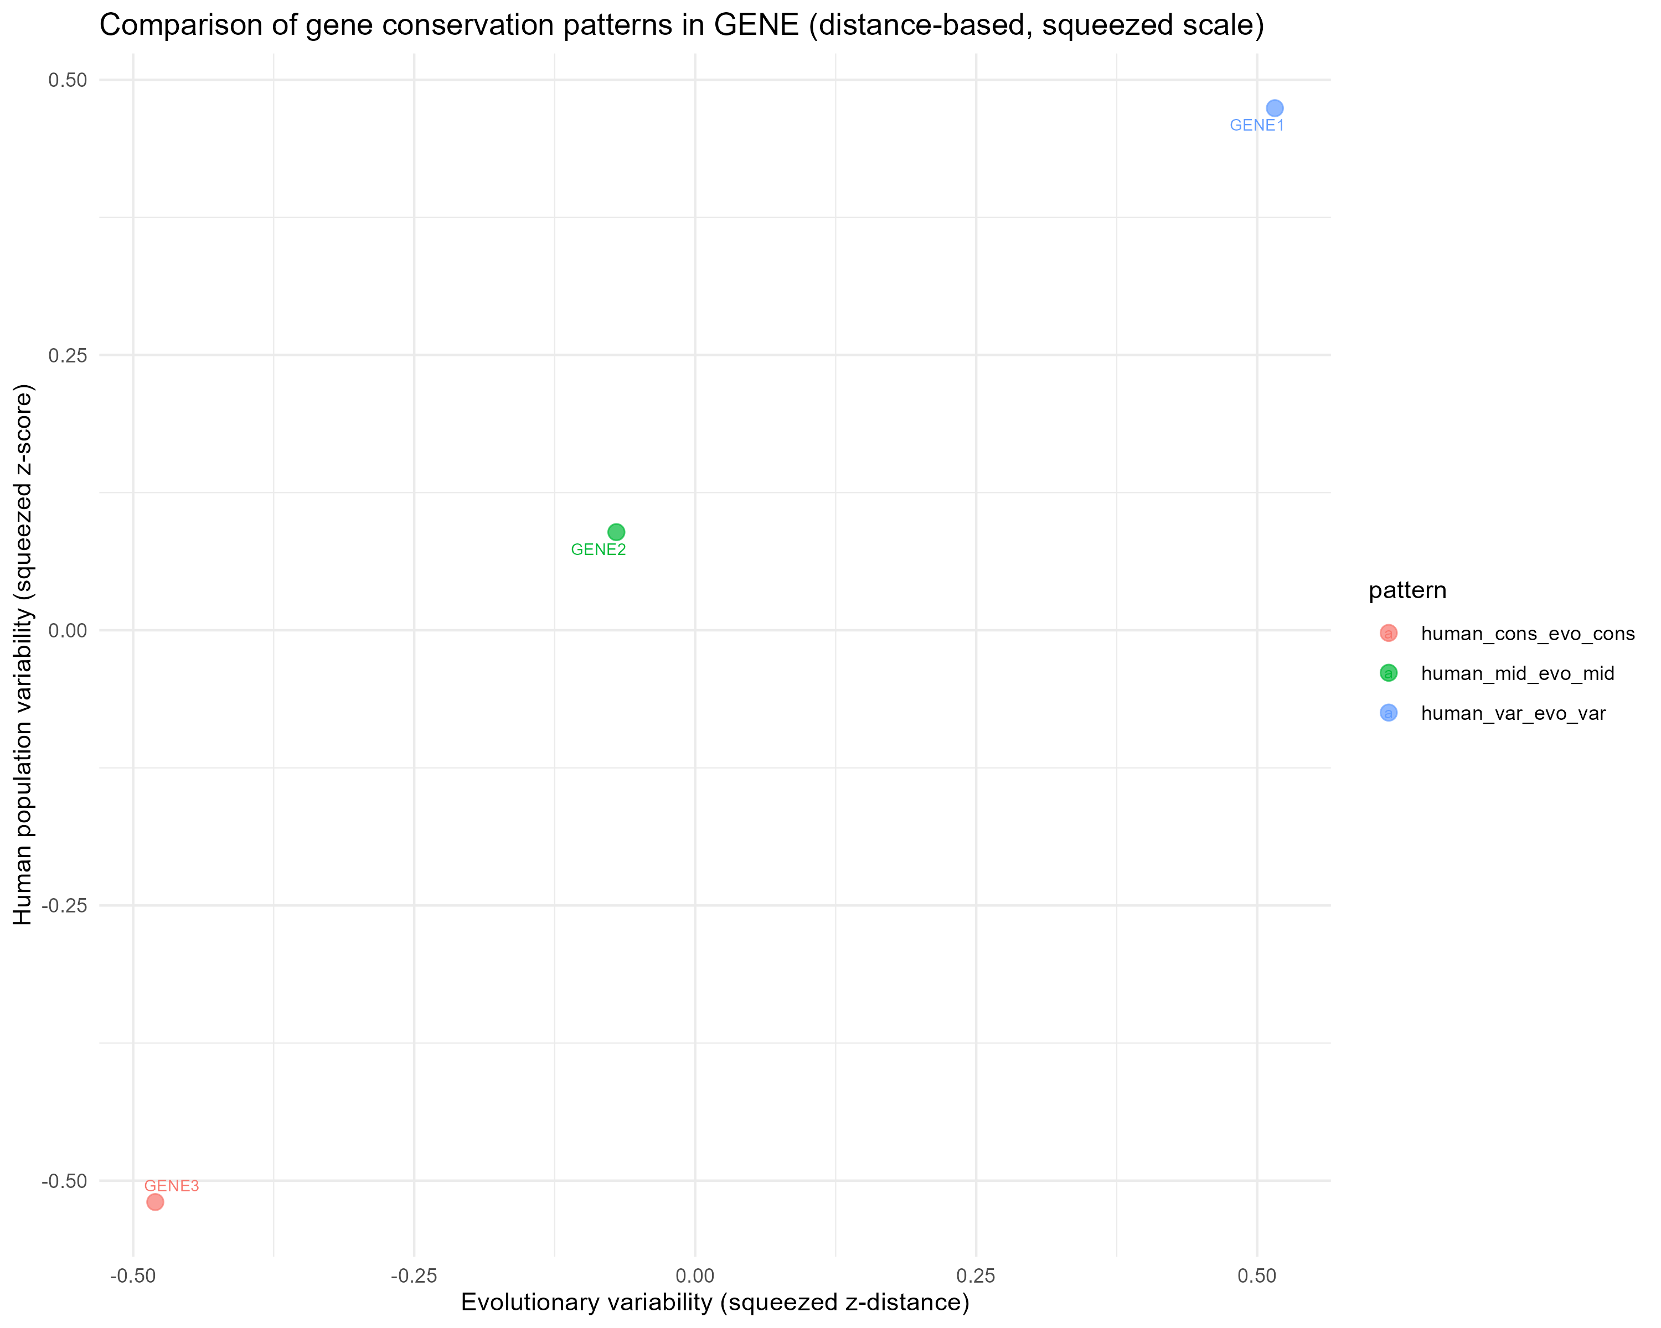
Figure 22 example GENE_dist.png

- Combined comparison plots when both metrics are available (<GENE>_both.png)
- Scale: squeezed z-scores
- Color: human variability class
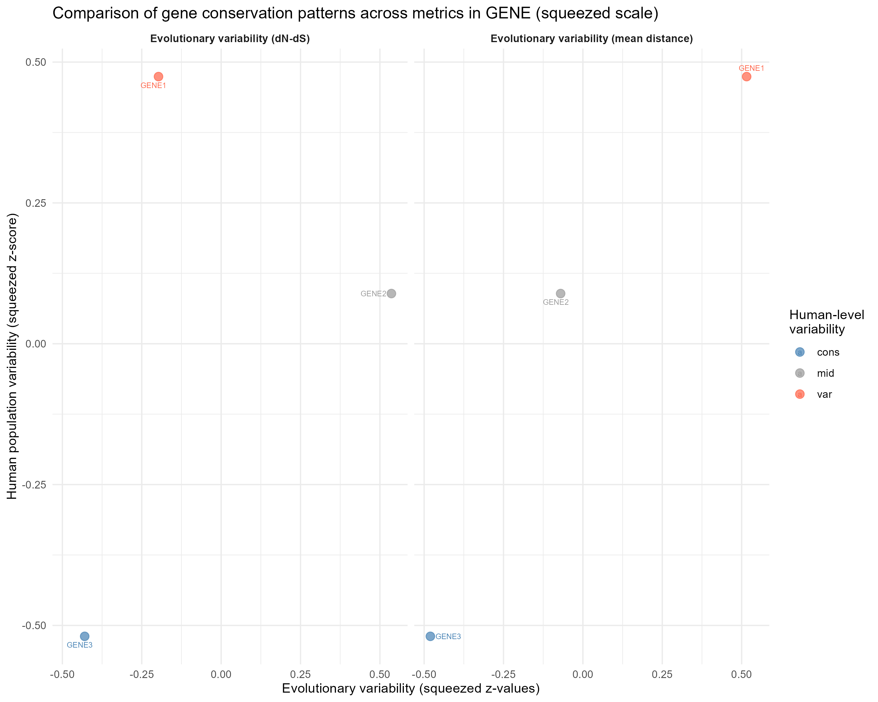
Figure 23 example GENE_both.png

3.5.3 Steps
- MSA file discovery
- Identifies all FASTA files (*.fas, *.fasta) in --msa_dir matching the target gene name (case-insensitive) and extracts segment identifiers from MSA filenames.

- Reading evolutionary matrices
- Distance and dN–dS matrices are read per segment when available.
- Distance matrices are reshaped into long format.
- P-values of dN–dS are adjusted for multiple testing using the Benjamini–Hochberg method.

- Gene matching across species
- Human genes are identified by the _Hsa suffix in MSA sequence names.
- Non-human homologs are matched based on shared gene name prefixes.
- Only homologs consistent with the inferred gene core are retained.

- Computation of evolutionary summaries
- For each human gene, evolutionary metrics are summarized across matched non-human homologs:
  - mean and median evolutionary distance
  - mean and median dN–dS (significant comparisons only)
- Genes without valid homologs are retained with missing values.

- Integration with human variability scores
- Evolutionary summaries are merged with gene_scores by gene identifier.

- Distribution histograms for:
- human variability scores
- mean dN–dS (if available)
- mean evolutionary distance (if available)

- Spearman correlations are computed between:
- human variability and mean dN–dS
- human variability and mean evolutionary distance
- Optional linear regression models are fitted when detailed = TRUE.

- Comparative visualization
- Human variability is compared against:
  - dN–dS–based evolutionary variability
  - distance-based evolutionary variability
- Scores are z-transformed and compressed using an arctangent transformation for visualization.
- Genes are categorized into conserved, intermediate, and variable groups based on quantiles.
- Combined plots are generated when both evolutionary metrics are present.

3.5.4 Notes
- Evolutionary comparisons rely solely on gene naming conventions in MSA files; sequence content and alignment length do not affect the analysis.
- dN–dS values are interpreted only when statistically significant after FDR correction.
- Distance- and dN–dS–based analyses are independent and can be run separately or jointly.
- Z-score squeezing is applied exclusively for visualization to reduce the influence of extreme values.

3.6 Step 3 - Haplotypes

3.6.1 Input
Previously generated objects: locus, snv_final, indel_final, sv_final, output_dir, gene_name, sample_region.

3.6.2 Output
Plots are saved under <output_dir>/haplotypes/:
- Average allele count per gene (<GENE>_top_var.png)
- Color: region
- Facets: gene
- Y-axis: mean allele count
- top 16 genes with highest variance across regions
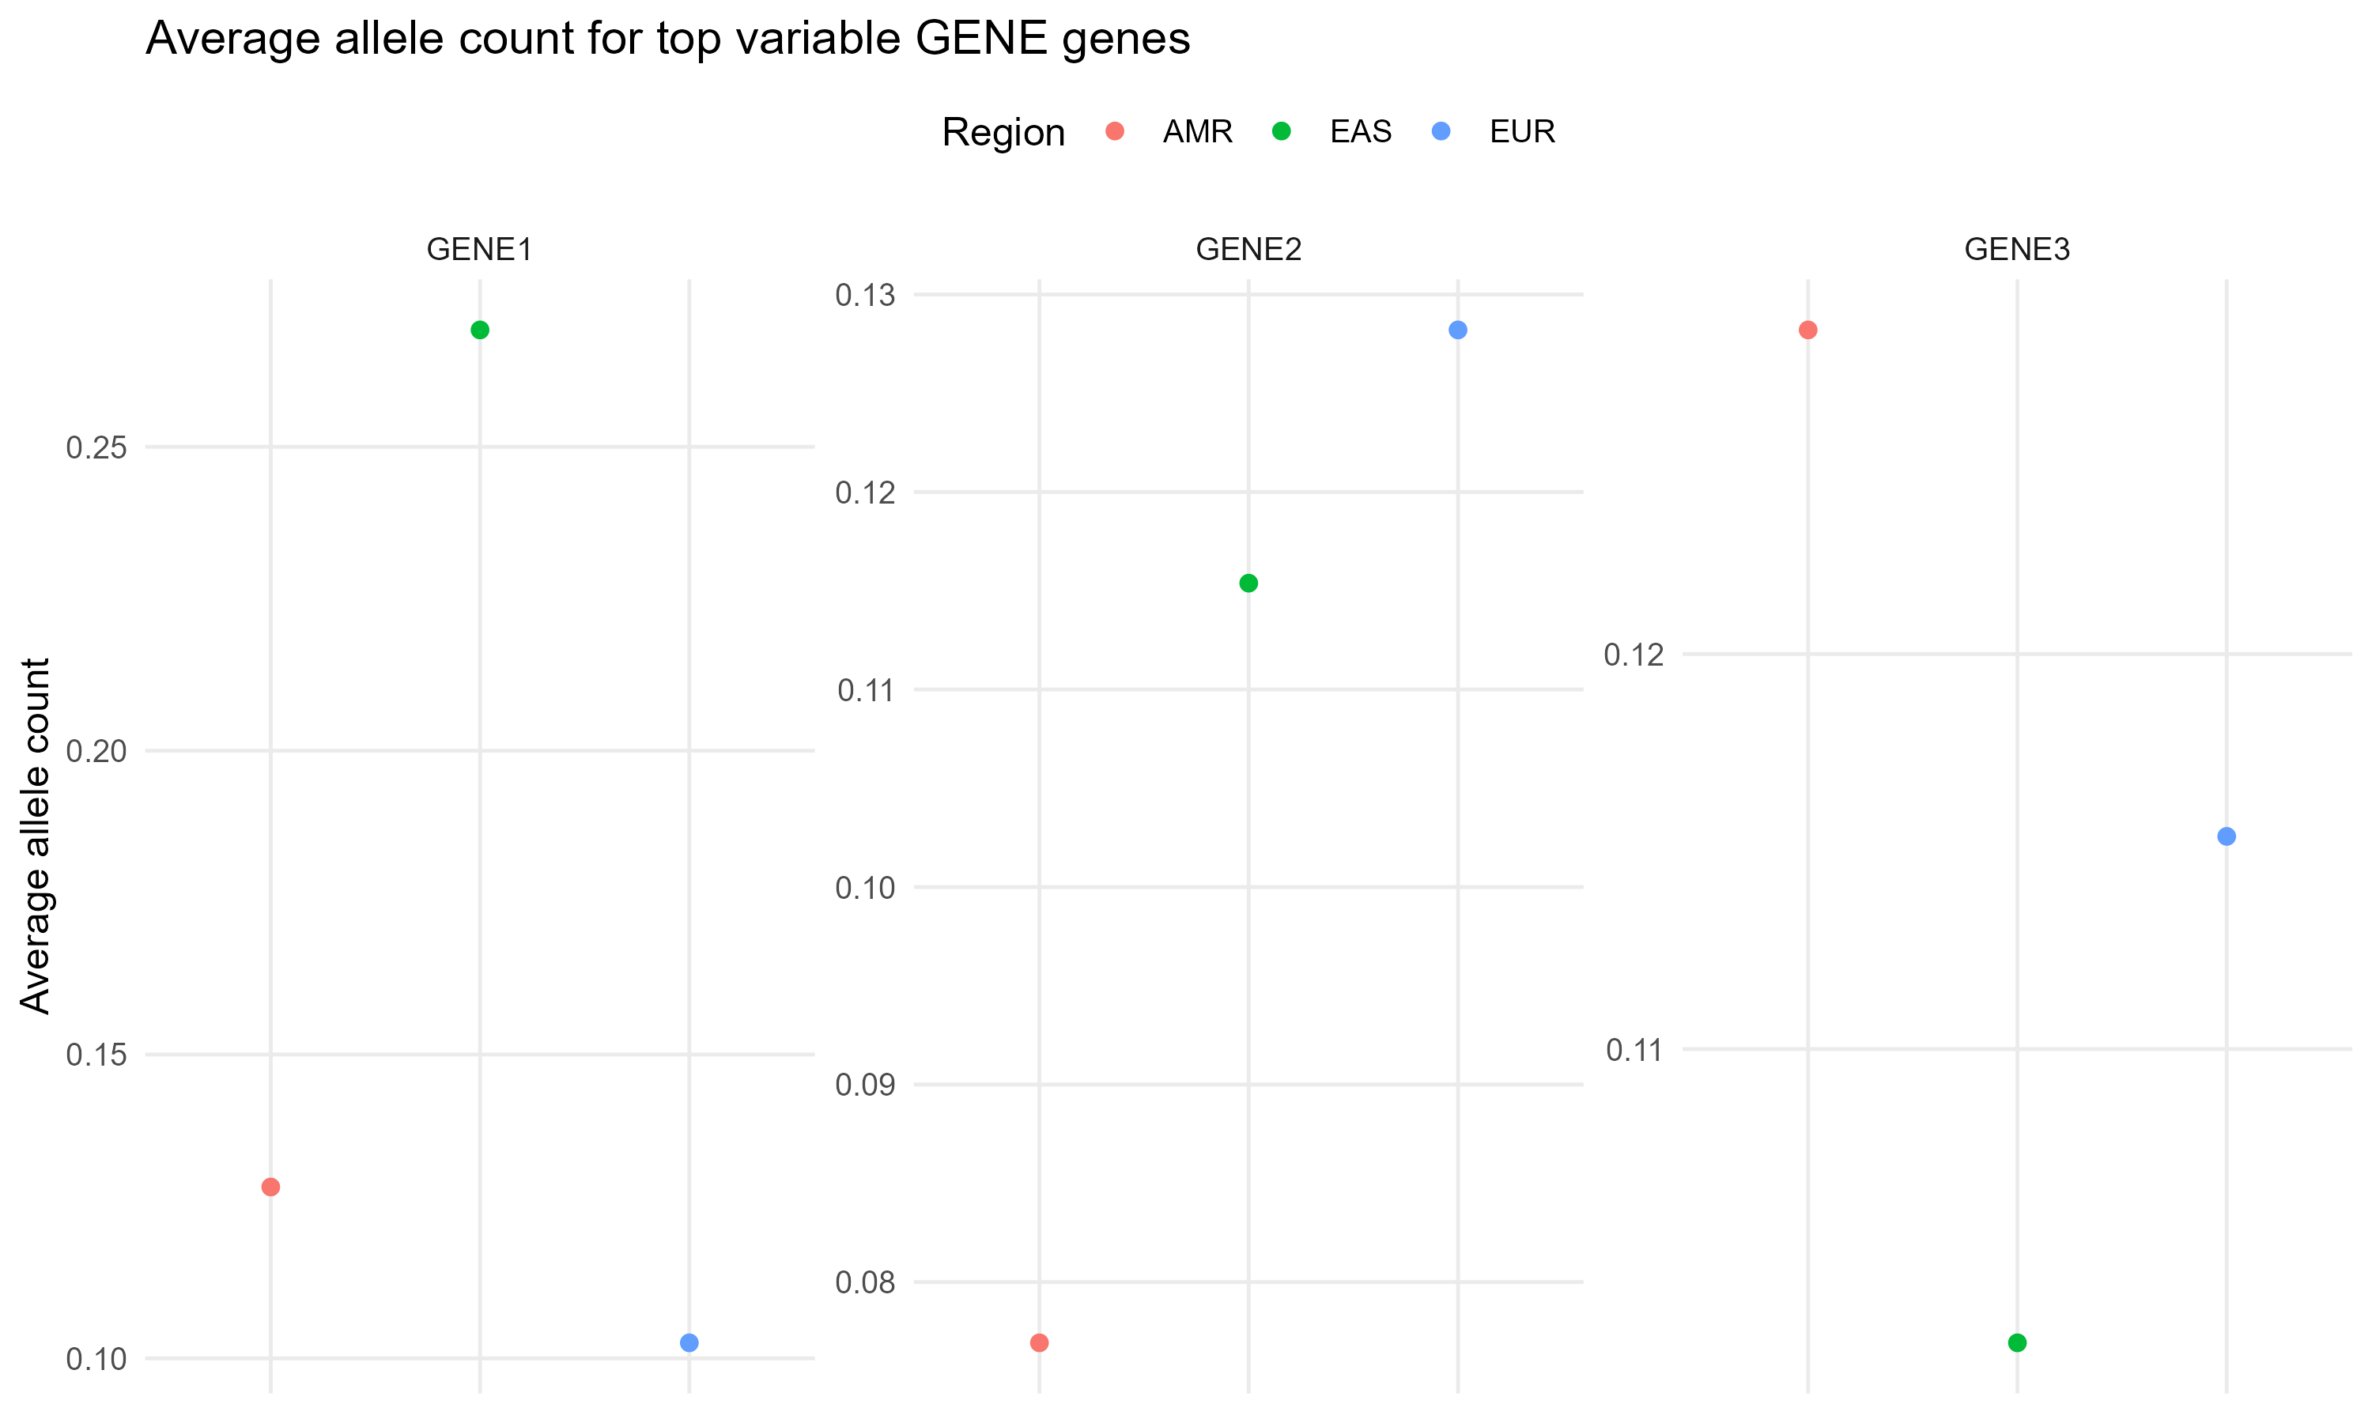
Figure 24 example GENE_top_var.png

- Allele variant levels across regions (<GENE>_allele_variants.png)
- X-axis: gene
- Y-axis: mean allele count
- Color: region
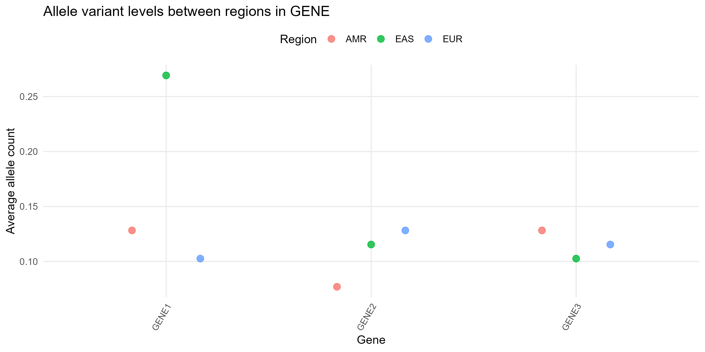
Figure 25 example GENE_allele_variants.png

Global comparison of allele counts between regions (boxplots) (<GENE>_global_region_boxplot.png)
- X-axis: region
- Y-axis: mean allele count
- Top 5 genes are labeled
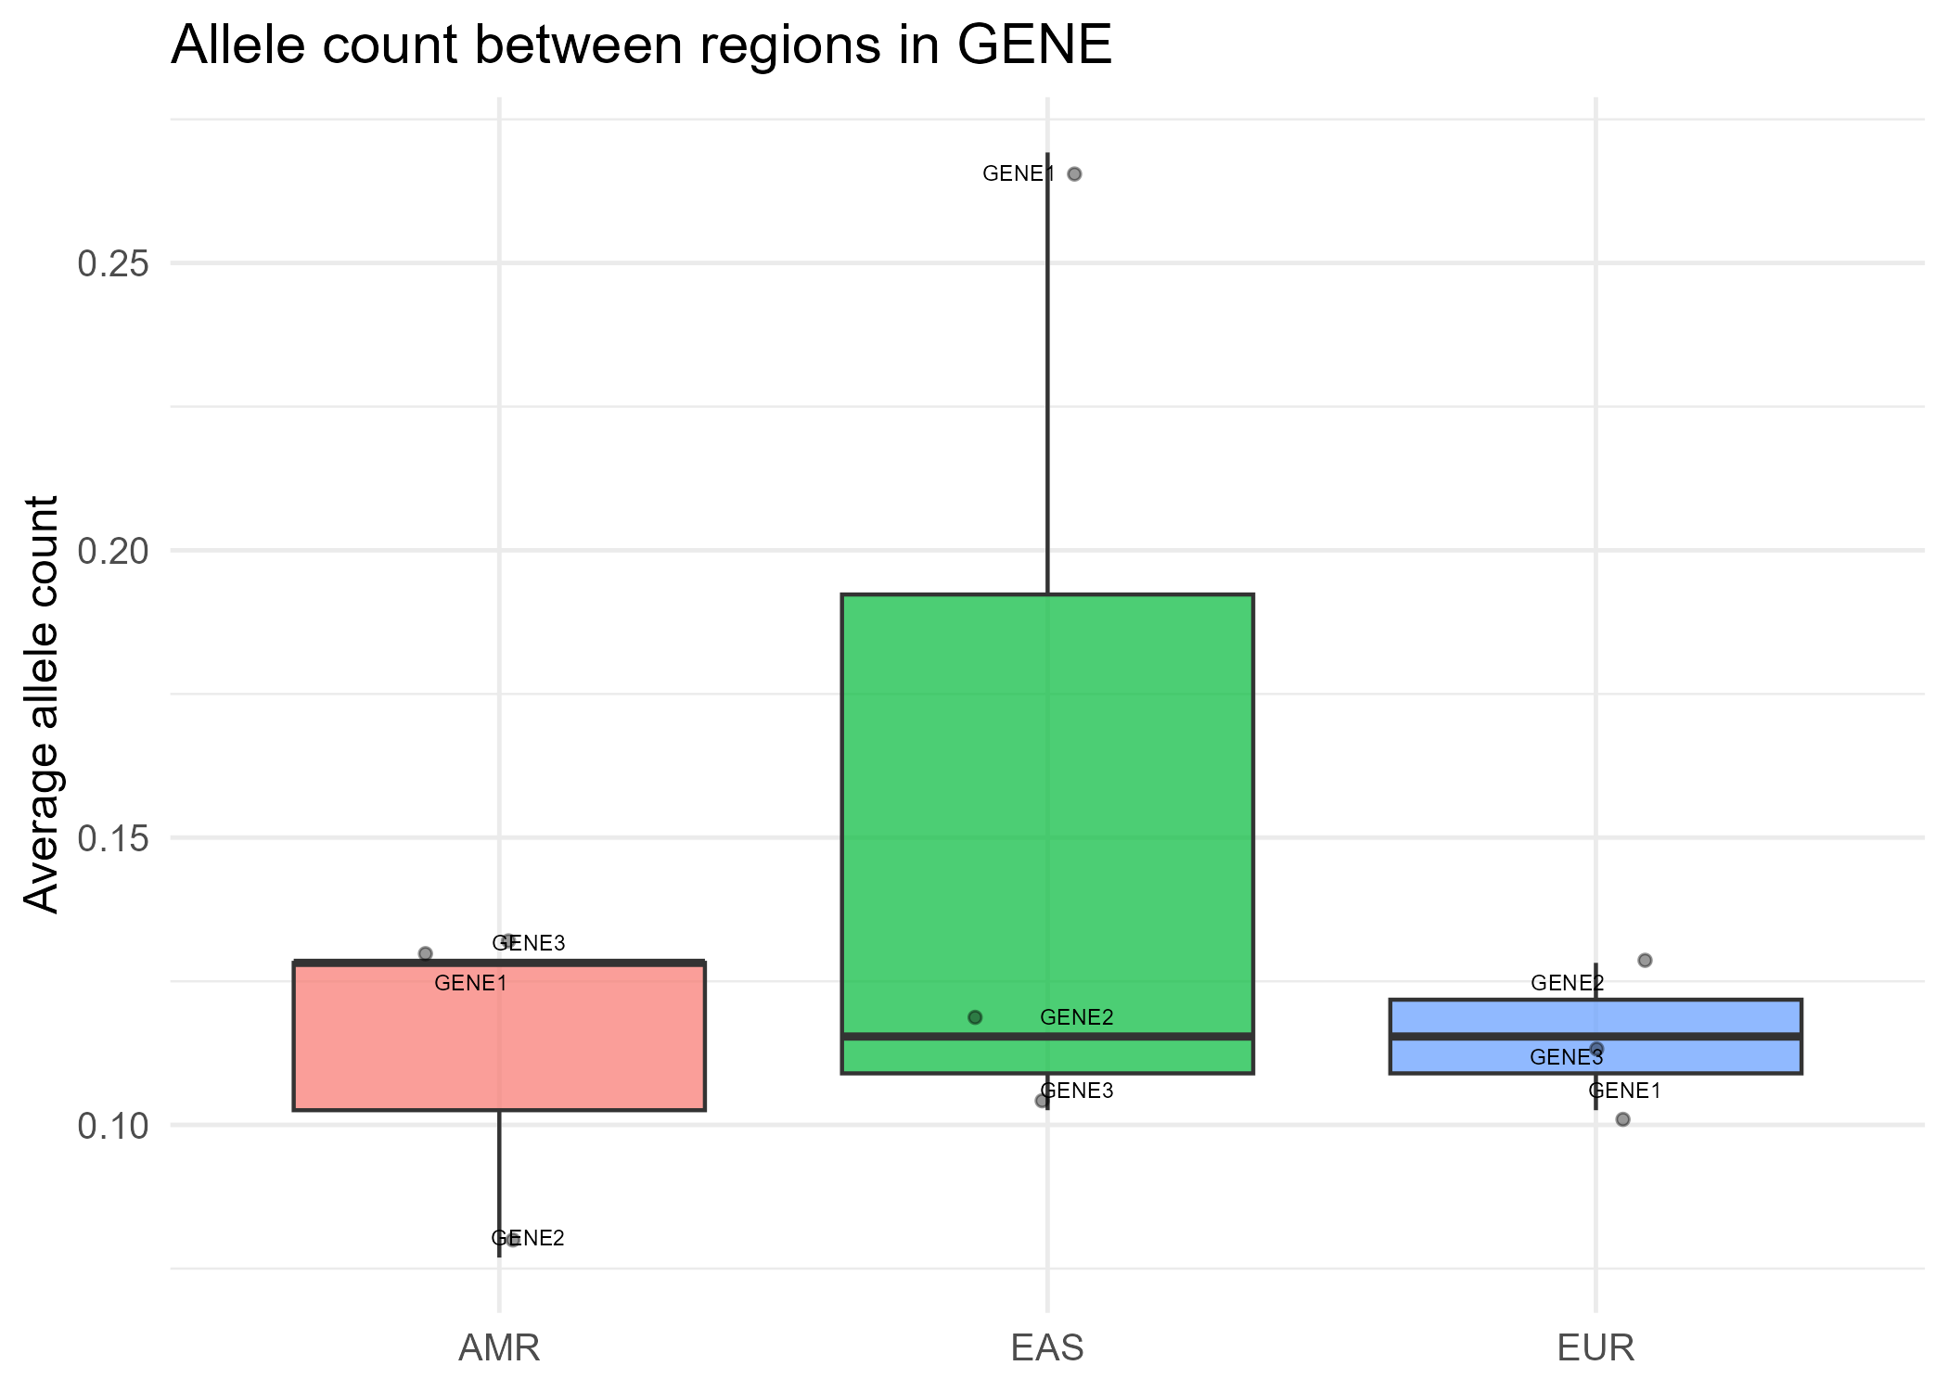
Figure 26 example GENE_global_region_boxplot.png

Normalized haplotype counts per gene (<GENE>_haplotype_summary.png)
- X-axis: gene
- Y-axis: haplotypes per kb
- Fill: Shannon diversity
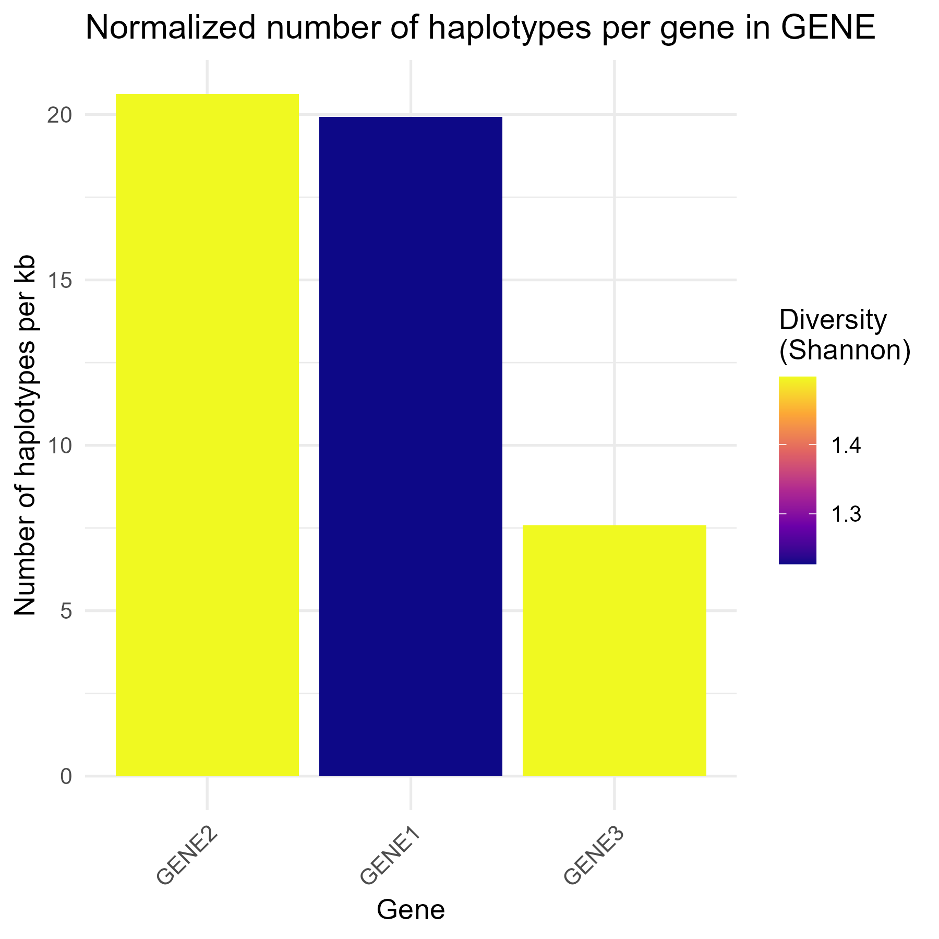
Figure 27 example GENE_haplotype_summary.png

Correlation heatmap of allele counts between regions (<GENE>_correlation.png)
- Row/column: regions
- Values: Spearman correlation of mean allele counts
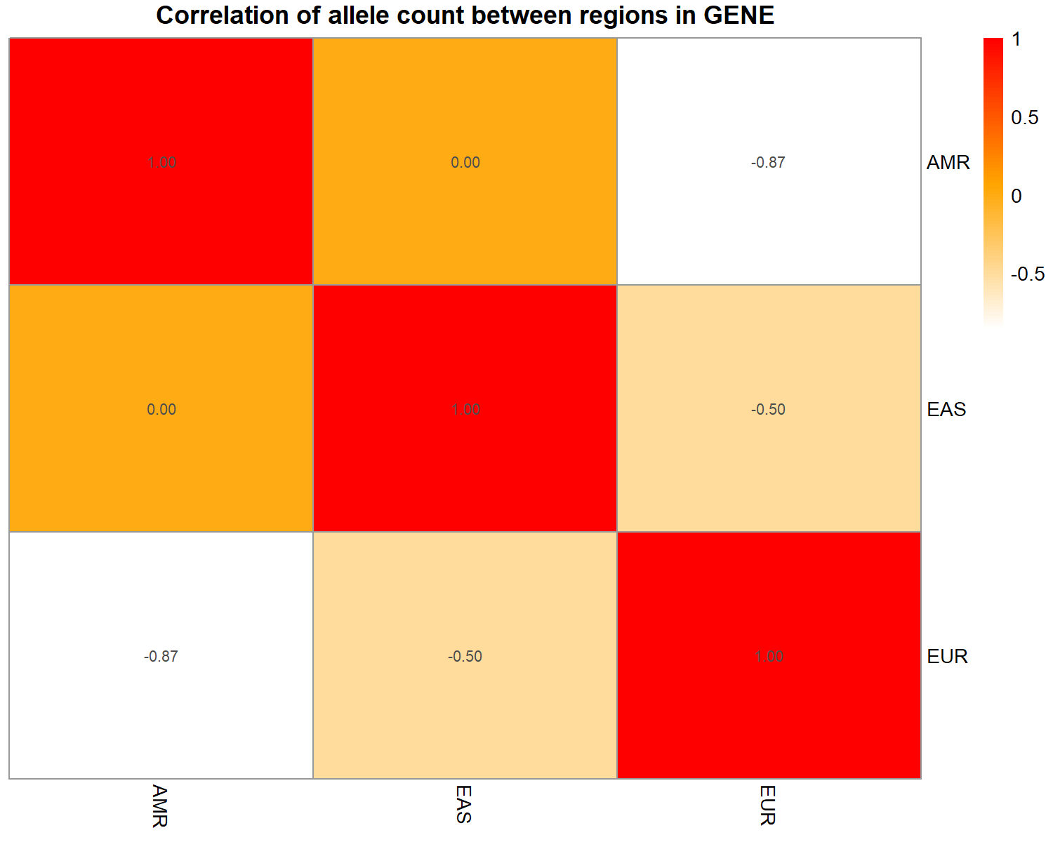
Figure 28 example GENE_correlation.png

Haplotypes per sample per region (faceted barplot) (<GENE>_haplotype_region_summary_v2.png)
- X-axis: gene
- Y-axis: haplotypes per sample
- Fill: Shannon diversity
- Facets: regions
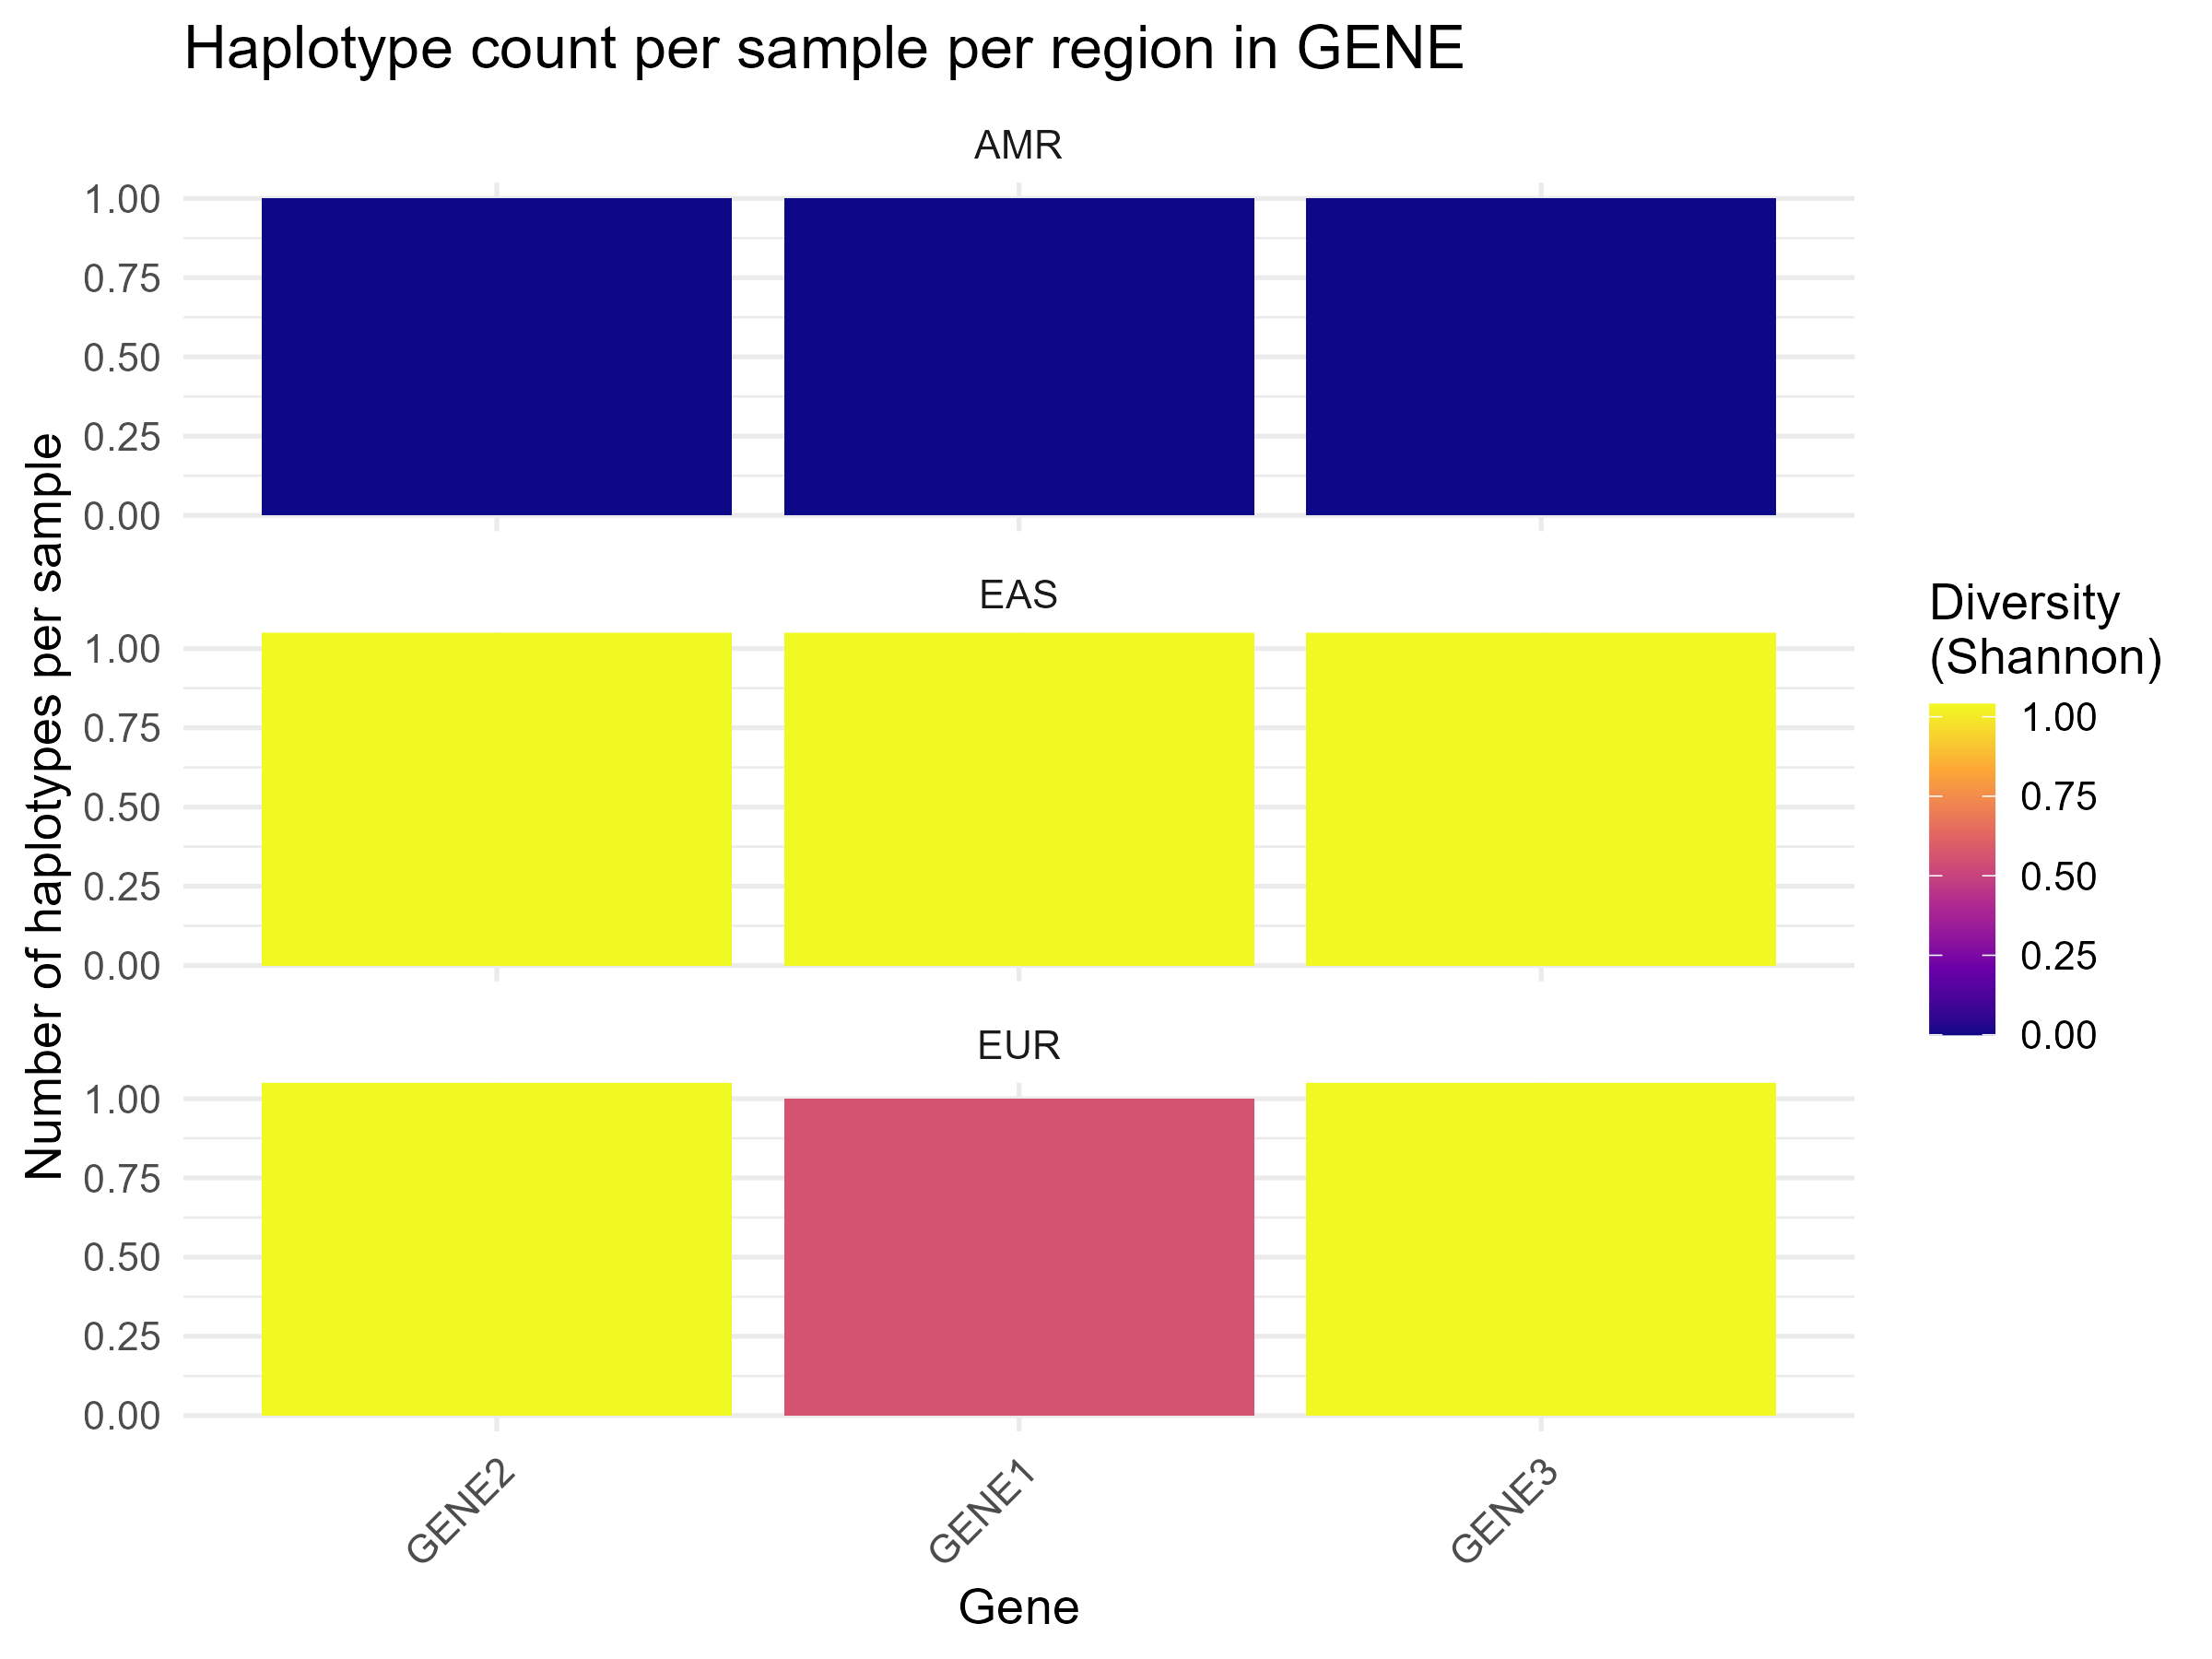
Figure 29 example GENE_haplotype_region_summary_v2.png

3.6.3 Steps
- Combine SNV, INDEL, and SV data into a single variant table

- Map each sample to region

- Construct a complete Sample × Variant × Gene grid

- Per gene:
- Identify loci with sufficient variability.
- Handle single-variable loci directly and multiple loci via EM-based haplotype estimation ((haplo.em()).
- Save haplotype table with frequency per haplotype.

- Summarize haplotypes:
- Number of haplotypes per gene.
- Diversity (Shannon index).
- Normalization by gene length (haplotypes per kb).

- Aggregate per-region haplotype summaries:
- Number of haplotypes per sample.
- Shannon diversity per gene/region.

- Generate visualizations

3.6.4 Notes
- Genes with insufficient variability are treated as monomorphic.
- For single-variable loci, haplotypes are computed directly, bypassing EM.
- EM-based haplotype estimation is used when multiple loci show variability.
- Haplotypes are normalized by gene length for cross-gene comparison.
- Correlation heatmaps summarize allele sharing across regions.

